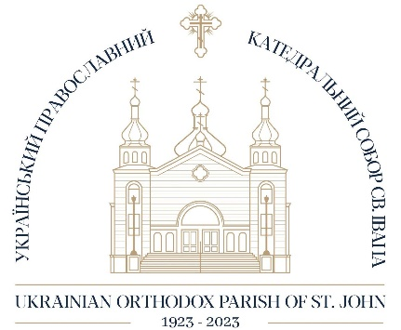
ST. JOHN’S UKRAINIAN ORTHODOX CATHEDRAL
100TH ANNIVERSARY SCHEDULE

MARCH 12, 2023 A CENTURY OF EXPRESSING THE ORTHODOX FAITH
A Fellowship presentation led by Father Cornell Zubritsky
MARCH 19, 2023 A CENTURY OF EXPRESSING THE ORTHODOX FAITH
A Fellowship presentation led by Father Cornell Zubritsky
APRIL 2, 2023 A CENTURY OF EXPRESSING THE ORTHODOX FAITH
A Fellowship presentation led by Father Cornell Zubritsky
APRIL 4TH – 8TH 100TH ANNIVERSARY EDITION OF PICTORAL DIRECTORY
APRIL 23, 2023 PARISH COMMUNAL EASTER DINNER
MAY 28TH, 2023 A Fellowship presentation of our history presented by Jean-Paul Himka
JUNE 9TH, 2023 OFFICIAL OPENING OF THE UKRAINIAN MUSEUM OF CANADA
ALBERTA BRANCH
JUNE 25TH, 2023 A Fellowship presentation of our history presented by Jean-Paul Himka
SEPTEMBER 17TH, 2023 A Fellowship presentation of our history presented by Jean-Paul Himka
SEPTEMBER 2023 100th anniversary & TYC Edmonton Golf Tournament
SEPTEMBER 23RD, 2023 CYMK CHOIR REUNION
OCTOBER 15, 2023 A Fellowship presentation of our history presented by Jean-Paul Himka
CLOSING
NOVEMBER 17TH, 2023 SACRED MUSIC CONCERT – St. John’s Cathedral
NOVEMBER 18TH, 2023 ANNIVERSARY BANQUET – St John’s Cultural Centre
NOVEMBER 19TH, 2023 HIERARCGAL DIVINE LITURGY – St. John’s Cathedral

