“100 YEARS OF PREACHING GOD’S WORD”
The first in the Jubilee Lecture series by Father Cornell
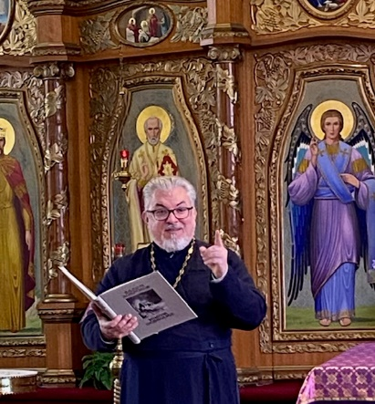
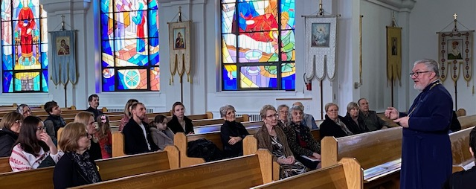
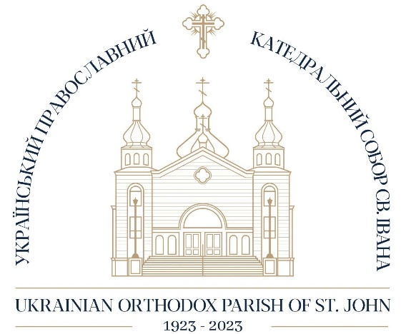

Archpriest Cornell Zubritsky kept an audience of about 45 participants intrigued with his presentation about our Cathedral temple’s history, iconography etc. on Sunday, March 12.
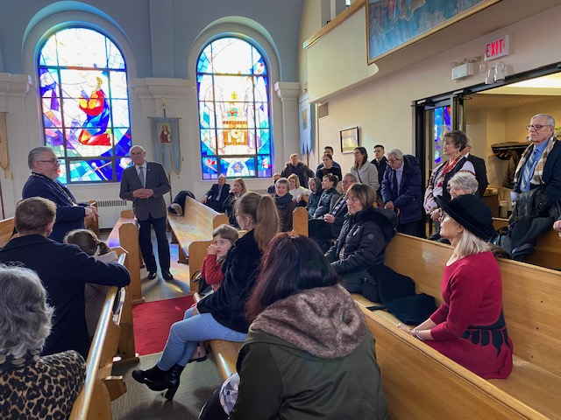
Two more in the series are planned
after Fellowship lunch:
March 19
April 2

