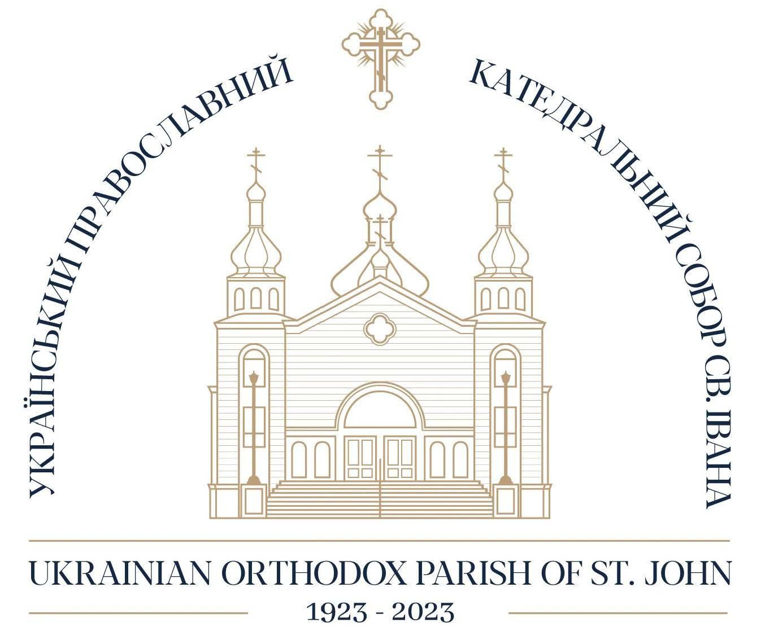

1978

1988

1978
The Mosaic installed on the arch about the Iconostas

1980
The bronze doors were installed, as a gift from the Krysa Family.

1982
Mosaic installed on the outside front wall and on either side of the entrance doors

1982
The Parish celebrate the “Year of the Ukrainian Orthodox Youth”.

1983
The Parish celebrate its 60th Anniversary

1983
Junior CYMK won the Baziuk Trophy as the best Junior CYMK in Canada.

1984
The Senior Citizen Home (Dnipro) was officially opened.

1984
The 17th Sobor elected Bishop John as Bishop of Edmonton and the Western Diocese.

1987
Junior CYMK won the Baziuk Trophy as the best CYMK in Canada.

1988
The Western Diocese celebrated the 1000th Anniversary of the acceptance of Christianity in Ukraine. In celebration of the memorable occasion, a Time Capsule was placed near the cornerstone of the Cathedral, and the children of the parish helped release 1,000 blue and yellow balloons.

1988
Two large stained glass windows were installed in the wings of the Cathedral on the large windows.

1988
The Hawrysh Scholarship was established.

