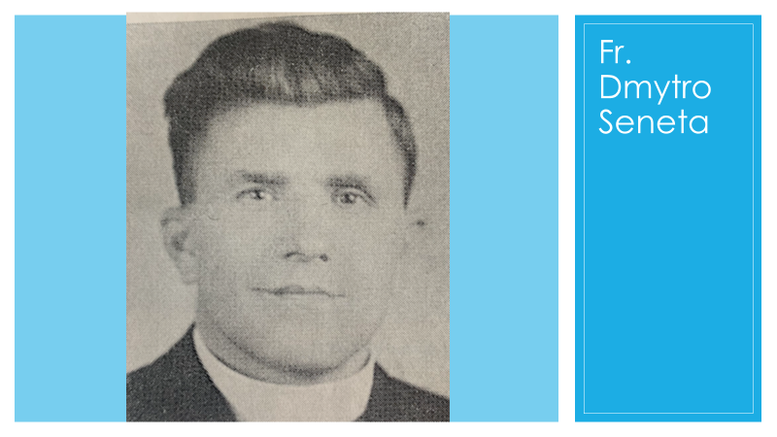

The First Pastor: Fr. Dmytro Seneta

The first task after the parish was established in November 1923 was to find and engage a priest, who was to be shared with Radway and Buford. (Buford is about 60 km southwest of Edmonton, Radway about 75 km northeast.) In spite of the consensus in the Ukrainian Greek Orthodox Church of Canada (hereafter I’ll just use the abbreviation UGOCC) that it had to educate its own clergy and not import priests from the old country or from other denominations, the first priest assigned to St. John’s was Fr. Dmytro Seneta. He had been serving in the Greek Catholic eparchy of Stanyslaviv in Galicia and was brought to Canada to serve the Edmonton parish through the mediation of Peter Svarich of Vegreville. Fr. Seneta was received into the UGOCC on 23 April 1924.

Within months, however, he and his parishioners were already at odds. By spring 1925, the president of the brotherhood was denouncing the pastor to the consistory in Winnipeg as nothing less than “an idiot, good-for-nothing, and Catholic youngster.” Part of the problem was circumstances – the Orthodox community in Edmonton was scrimping to hire Fr. Seneta, and there were various conflicts over money. There was also a clash of expectations: the Canadians were looking for someone who would undertake pioneering work in a new church, and the priest had come out of an environment where the clergy drew a state salary and lived like the gentry. The UGOCC was a church oriented on the community, on the laity, and that was certainly not the situation back in the old country.
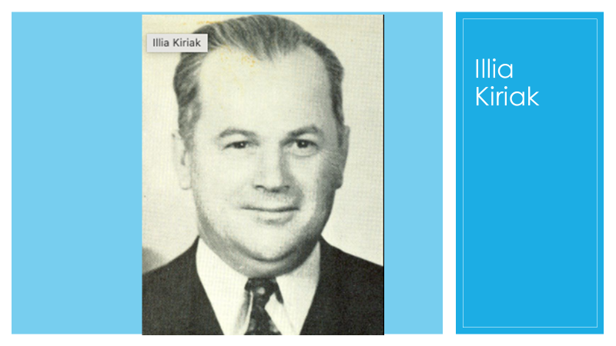

But looking back at these tensions almost a century later, it seems that much of the conflict had its roots in Fr. Seneta’s unique personality. The writer Illia Kiriak had harsh words about the priest. He wrote to Myroslaw Stechishin on 6 April 1927: “Anyone who knows Fr. Seneta better will tell you: This is a stubborn man who never admits to being in the wrong, and what’s worse, he will never forgive anyone the least bit of foolishness. He’s ambitious, arrogant, and a loner.” Even Svarich, who had been instrumental in bringing him to Edmonton, at a meeting of the brotherhood on 28 December 1924 admitted that “Fr. Seneta is a man of pessimistic attitude. Nonetheless, he has his good sides, although one must admit that he does not have organizational abilities, and besides he doesn’t keep his word, and he embitters people against himself and the church.”
The historian Orest Martynowych, who had studied the archival documentation on Fr. Seneta, came to the conclusion that the clergyman was a “tortured soul.” And indeed, this makes sense. Fr. Seneta had difficulty finding a spiritual home. He left the Greek Catholic church in Galicia to join the newly formed Ukrainian Greek Orthodox church in Canada. But by 1930 he was negotiating with the Ukrainian Greek Catholics to be accepted back into that church. However, the Roman Catholic Archbishop of Winnipeg, Alfred Arthur Sinnott, stipulated that Fr. Seneta would have to send his wife and children back to Galicia if he wanted to serve as a Greek Catholic priest in Canada. This was not acceptable to Fr. Seneta, who was soon to join a third church, the Ukrainian Orthodox Church of America (the so-called Zukites or zhukivtsi). In that capacity he tried to attract parishes, notably the one in Canora, SK, away from the UGOCC to the rival American church. He was certainly a man of unsettled disposition.

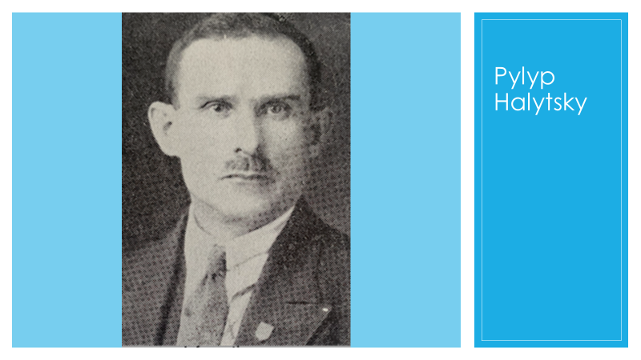

According to Kiriak, in the aforementioned letter, the Orthodox brotherhood was also irritated by how Fr. Seneta ran the choir. However, we need to be aware that Kiriak’s description of events proceeded from a highly partisan position representing one of the divisions among the nationalists at the time. In any case, the choir, composed of students resident at the Hrushevsky Institute, came into existence late in 1924 and was at first directed by Pylyp Halytsky, an Institute employee. But then the pastor assumed responsibility for the choir, and some of the students stopped coming to choir rehearsals. When Halytsky returned to the Institute after a period spent in the block settlement northeast of Edmonton, some of the students asked him to return as singing instructor, since Fr. Seneta’s instruction was only suitable for those choristers who were able to read music. Halytsky tried to work things out with Fr. Seneta, but the priest did not even want to discuss the matter. Halytsky himself joined the choir and brought with him some of the residents who had been boycotting practices. Fr. Seneta taught the choir from his own sheet music, but he would hide the music between rehearsals. Choir members were expected to memorize their parts before singing during services. Since Fr. Seneta could not himself be in the choir when he was celebrating the liturgy, he had Halytsky direct it. Yet when Halytsky asked for the sheet music, the priest refused to share it. Halytsky went on strike: he came to church but he wouldn’t take part in the choir. Instead of a choir singing at the service, the parish engaged in traditional congregational singing. Symptomatic of the problem was that in fall 1925 the brotherhood was reluctant to organize a hierarchical liturgy for an episcopal visitation because there was no choir to sing it.
The tensions in the parish between pastor and flock reached the point that Fr. Seneta spent more time in the block settlement, “the colonies” as they were then called, than in Edmonton. In early 1926 St. John’s parish was struggling to schedule a liturgy even once a month, and it was looking to hire the overworked Fr. Ivan Kusey, who served several rural Albertan parishes, to come in twice a month to celebrate. Fr. Kusey could not come that often, but he agreed to serve as a temporary pastor and celebrate the liturgy from time to time. Eventually the bishop, Vladyka John Theodorovych, intervened during his visitation to Edmonton in 1926. The bishop, Wasyl Swystun, Fr. Kusey, the parish brotherhood, and Fr. Seneta held a special meeting on 16 August 1926. It lasted until 1:30 in the morning. At the end, the brotherhood and Fr. Seneta each admitted to being partially in the wrong and agreed to cooperate. Fr. Seneta consented to move back to Edmonton and to celebrate two liturgies a month there. The agreement held, but tensions did not completely abate. In 1927 the priest tendered his resignation. It was a rocky beginning for the parish.

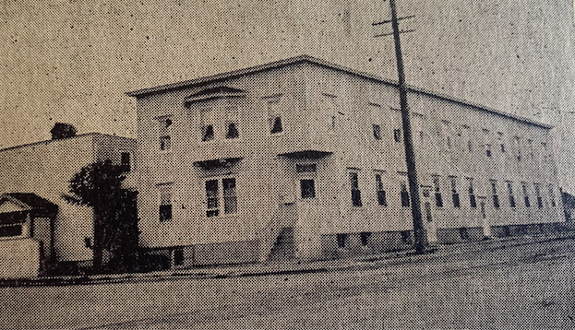

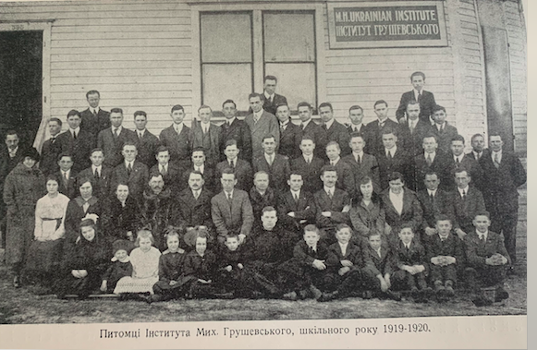

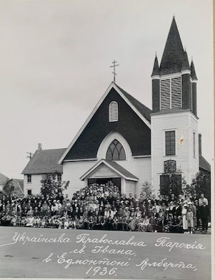

But on the bright side, the parish, which had been holding services in the Hrushevsky Institute or an Anglican church, was on the eve of acquiring its own church structure. A committee was struck on 28 March 1926 to investigate lots across the street from the Hrushevsky Institute where a church could be built. But later a better deal presented itself. At a meeting on 26 September 1926 the brotherhood decided to purchase an existing church, the Grace Methodist church at 10613-96 St. They took up a collection among themselves right then and there, and others contributed afterwards. The church, with all its furnishings, cost $6500, with half that amount as a down payment and the rest to be paid after two and a half months. The parish was able to raise $2200 among its members and the rest of the funds were borrowed. The church they were buying had a sloping floor, but it could seat four hundred
congregants.

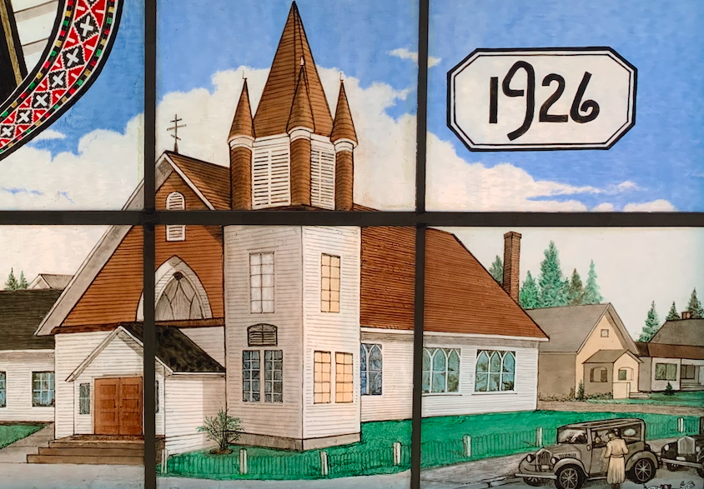
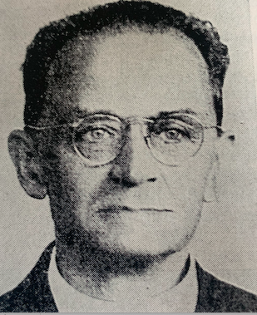

A New Pastor: Fr. Peter Bilon
The first Divine Liturgy in the newly purchased church was held on 24 October 1926. It was still served by Fr. Seneta.

But as of 18 September 1927, a new pastor celebrated the liturgy, Fr. Peter Bilon. Fr. Bilon was neither a Galician nor a Bukovinian but from central Ukraine, born in the ancient town of Vasylkiv, about 35 km southwest of Kyiv. He came from a prosperous and influential family. In fact, his father had served as mayor of Vasylkiv for a quarter of a century. During the revolutionary era Peter Bilon served in the air force of the Ukrainian People’s Republic. Later, while living in a POW in a camp in Poland, he decided to seek holy orders and was ordained by the Orthodox bishop of Grodno (now in Belarus) on 4 January 1921, the day of his forty-second birthday. He was an older and more experienced man than his predecessor had been, and before coming to Edmonton he had accumulated several years of pastoral experience in America and in Fort William, Ontario. He did not remain in Edmonton long, however, leaving near the end of March in 1928 to return to Fort William where he felt he was more needed. The church board tried to prevent him from leaving and wrote to the consistory to keep him in Edmonton permanently, but to no avail. Nonetheless, there were no hard feelings on the part of the board, which gifted Dobrodiika Klavdiia Bilon with a set of silver cutlery as a reminder of her service in Edmonton (together with her husband she taught in both the Sunday school and the Ridna Shkola, i.e., extracurricular courses in Ukrainian language and culture for school-age children).

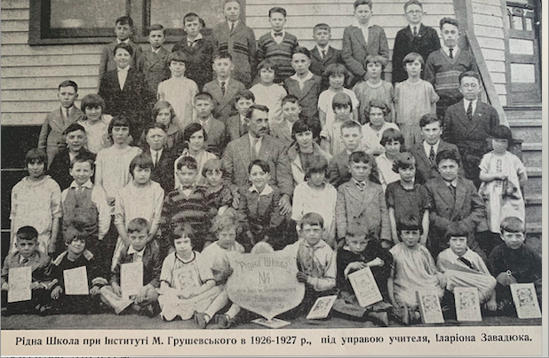

But what is particularly interesting about Fr. Bilon is that he was a keen observer and accomplished writer who left memoirs, including of his time in Edmonton. They provide a glimpse into what St. John’s was like in the six months he was there. From the beginning, he was very impressed with the congregation. “...I have to admit that it has been rare that I have met such good, sincere, and nice people as I met in Edmonton....The citizens of Edmonton were extraordinarily agreeable, friendly, and warm. From the first days when my family arrived in Edmonton they invited us to dinners, suppers, and specially arranged parties with singing and various games.” Fr. Bilon explained the generous character of the congregation in terms of its members’ social status. “It’s no wonder they were like that,” he wrote, “because the Edmonton Ukrainian community was composed entirely of so-called professionals, such as merchants, industrialists, factory owners, lawyers, doctors, owners of bookstores, hoteliers, and the like. Only such people belonged to the parish, and only two individuals were workers.”

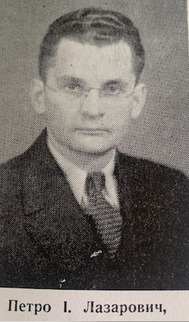

There was a humorous incident that resulted from the high social status of the parishioners. One day Fr. Bilon, accompanied by his friend and parishioner Peter Lazarowich, went to visit the office of Emanuel Michaliuk, a lawyer and the treasurer of St. John’s. Before the priest could even step inside, Michaliuk confronted him angrily and demanded that the priest never again insult him personally and publicly in church. It turned out that not long before, Fr. Bilon had delivered a sermon on the Publican and the Pharisee, and both Michaliuk and his wife imagined that the description of the Pharisee actually referred to Michaliuk. Michaliuk remained angry, but Fr. Bilon and Lazarowich had a hearty laugh afterwards about Michaliuk’s vision of himself as the Pharisee of the gospel.
Fr. Bilon was paid a salary of $100 a month. Although his parishioners on the whole lived quite well, he and his family struggled. In his memoirs, the pastor recounted: “As we see, the church board consisted of only ‘the elite,’ the most conscious individuals in the entire community, and one would think that nothing better could be wished for, but for us, Ukrainians, nothing is ever as it should be. And Edmonton was no exception to ‘the rule.’ The church leadership, as well as most parishioners, for no good reason and with no logic, looked at their priest as a hireling or slave who, in their opinion, had to perform a whole series of his, and not only his, responsibilities, but did not have the right to a living standard that was equivalent to that of their average parishioners.” Fr. Bilon tried not to let this bother him, however, since he recognized that he was a missionary priest, whose calling demanded sacrifices.
Overall, his recollections of his time in Edmonton were positive. He seriously considered returning to St. John’s in 1933, when he was so invited by the board. He would have preferred living in Canada rather than in the United States, where he was stationed at the time. He remembered his sojourn in Canada “with love,” and he felt that Ukrainian Canadians treated Ukrainians from central Ukraine, such as himself, much better than Ukrainian Americans did. Also, church and community life were better organized in Canada than in America. But he declined the offer from St. John’s. “We were scared off by the far, far distance and by the winter.” Perhaps he might have reconsidered a return to Edmonton more favorably if his original experience of the city had not been limited to the months September through March.

The Women’s Society

Before turning to an account of the tremendous work performed by the women of St. John’s parish, it is useful to consider the broader context. In 2000 the political scientist Robert D. Putnam published a groundbreaking study of American society entitled Bowling Alone. It pointed to a drastic decline of participation in all kinds of organizations, such as civic groups, the Rotary, labor unions, bowling leagues of course, and religious organizations (he cited as an example the Catholic order of the Knights of Columbus). He dated the beginning of the decline to the 1960s. This broad sociological trend was only intensified, to be sure, after digital communities began to replace in-person communities in the twenty-first century. That is why the image of the “perogy ladies” throughout the US and Canada is now associated with old women, “babas”: the women’s organizations that had supported churches through many decades could not, after a certain time, recruit a sufficient number of youth to replace their members; hence the aging of the membership. Probably in our community, the Ukrainian Orthodox community in Western Canada, the decline was evident at some point in the 1980s, although no one has ever studied this. In order to understand the situation in the early years of our parish, it is necessary to shed the perspective of the present and go back mentally to a time when people – men as well as women – were joiners. People made their friends (and sometimes, to be honest, their enemies) in social groups that were devoted either to some good cause or to collective refreshment and enjoyment – glee clubs, the Lions Club, junior chambers of commerce, and organizations associated with a particular church. If one looks at a photo of the St. John’s women’s group in 1927, one is pleasantly surprised by all the young faces peering into the camera. And after looking at what those women were accomplishing in the 1920s and for perhaps a half century thereafter, one cannot help but marvel at their incredible energy, fueled by their youth.
The history of Ukrainian women’s activism in Edmonton dates back to 1913, when women raised funds for the Ivan Franko Educational Society. When the Mykhailo Hrushevsky Institute was founded in 1918, many of the same women, organized as the Lesia Ukrainka Society, turned to raising funds for the institute. As an example of what could be accomplished, in April 1926 the society, at the behest of the Institute and under the leadership of the Institute director’s wife, Maria Michalyshyn, held a bazaar that earned $1600. According to Illia Kiriak, the society in that year boasted forty-two women, the majority of whom (twenty-five) were Orthodox. Later in the year, however, the Orthodox women began to raise funds primarily for the parish, since the newly purchased church required considerable financial input. This raised the hackles of some members of the Institute, Kiriak included, who felt that the purchase of a church should have been postponed until the Institute had acquired a firmer financial footing. In spite of these objections, the Orthodox women formally constituted themselves as the Women’s Society (Zhinoche tovarystvo) on 26 August 1926. Its first leaders were, for the most part, the wives of church board members. Two years later, the Ukrainian Women’s Association (Soiuz ukrainok), also known as the Ukrainian Ladies’ Aid Society, was established, and the Women’s Society at St. John’s joined it on 27 March 1929.
The primary aim of the Women’s Society was to raise money for the church. To do this, the women put on bazaars, dinners, teas, lectures, debates, and theatrical performances. Back then, tag days were popular. These were days on which charities, after receiving permission from the municipal authorities, collected money; when you donated, you received a tag. The Orthodox women would take to the streets with their children to solicit donations. To plan and organize all these events, the women at first had to meet every week. The results of their efforts were impressive. In the period 1926-39, the women’s society collected $12,922.63 for St. John’s. This amount was about twice that of the original purchase price of the church, thus a very substantial contribution. In 1947 the Women’s Society, which boasted 118 members, put on twenty dinners, five dances, two surprise parties, five suppers, and a bazaar, and was able to donate $3150 to the church. In 1955 the society was able to donate $25,860.26 to the church; for comparison the average price of a new house in Canada at that time was $22,000.
The women’s activities earned them respect. Women were first allowed a voice at board meetings in 1927 and in the following year they were granted the right to vote at the annual general meetings of the church. At a church board meeting on 13 November 1933, a letter was read from past president Harry Michalyshyn. He singled out the Women’s Society “for its generous work and material support for the church community. If it were not for the Women’s Society and its dedication and magnanimous labor, the affairs of our church would have been in a rather poor condition. Therefore, I thank the Women’s Society in the name of the board for its cooperation and support over the whole of the past year and wish your Women’s Society to grow great and strong.” Earlier, in 1930, Paul Melnyk said at a meeting of the board: “Our organization would be worth very little if it weren’t for the Women’s Society.” Fr. Peter Sametz, who served as pastor at St. John’s in 1928-33, wrote this little encomium in his memoir: “The Edmonton parish was particularly blessed with a very active, bright and gifted Women’s Association at the church. It organized the church choir, the Sunday Schools and the Ukrainian language schools and made sure that all events at the church hummed with activity....We often say that of the four corners of the church at least three are supported by the women.”

Paul Melnyk Father Peter Sametz

