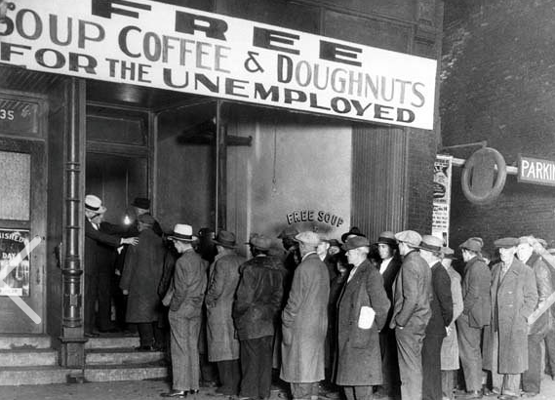
Dytro Proniuk

The Depression
The early 1930s were a difficult period throughout the world. Alberta was better off than Saskatchewan, but that’s not saying much. Unemployment reached sky-high levels, and even lawyers, doctors, and businessmen received government assistance. The professionals and businessmen of St. John’s parish were not spared economic hardship. As consumers reduced purchases, many businesses wobbled on the verge of bankruptcy, e.g. the tailor shop of one of the founders and leaders of the parish, Dmytro Proniuk.
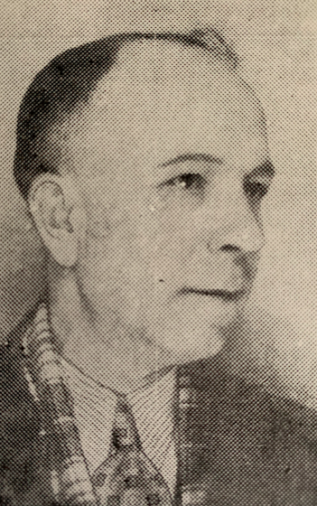

DMYTRO PRONIUK

The difficult straits found reflection in the minutes of the parish council: “We’re not able to maintain our pastor” (5 January 1930). “Difficult material conditions” (27 September 1930). “Three times worse than previous years” (19 January 1931). “A difficult year” (17 January 1932 and 29 June 1933). “There’s $79.91 in the account” (17 February 1932). “In the bank and cash in hand $22.63 are left” (22 January 1933). “There is no money in the account” (20 and 27 July 1933). “There are only $14 in the account....The collection plate brings in on average $10....1933 was harder than previous years” (17 September 1933). «Many members haven’t paid their dues for several years and are starving” (5 March 1934). “There are $6.58 in the account” (22 April 1934).
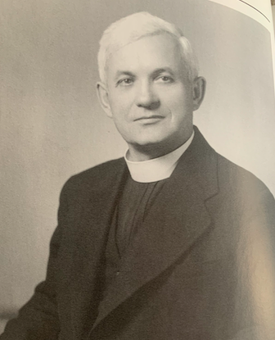

FATHER PETER SAMETZ

DMYTRO PRONIUK

DMYTRO PRONIUK

RONIUK
The pastor, Fr. Peter Sametz, agreed to a reduction of his salary from $100 to $75 a month, but in September 1933 the parish could only pay him $60. At the same time, the depression created additional pastoral responsibilities for the priest. In the early 1930s the Canadian government was deporting many out-of-work Ukrainians, mainly single men. Fr. Sametz managed to save several of them from deportation. He also held a talk warning about the growth of procommunist sympathies among the Ukrainian laboring class as a result of the economic situation.
The parish undertook some minor relief efforts. In 1930 it distributed pasky to poor families. Individual parishioners also helped their fellow Ukrainians. Nick and Pearl Mendryk, for example, owned a rooming house in Edmonton; during the depression they fed hungry Ukrainians who could not afford a meal.
By the second half of 1934 the worst effects of the depression were over, and the parish was able to replenish its funds and undertake new projects.

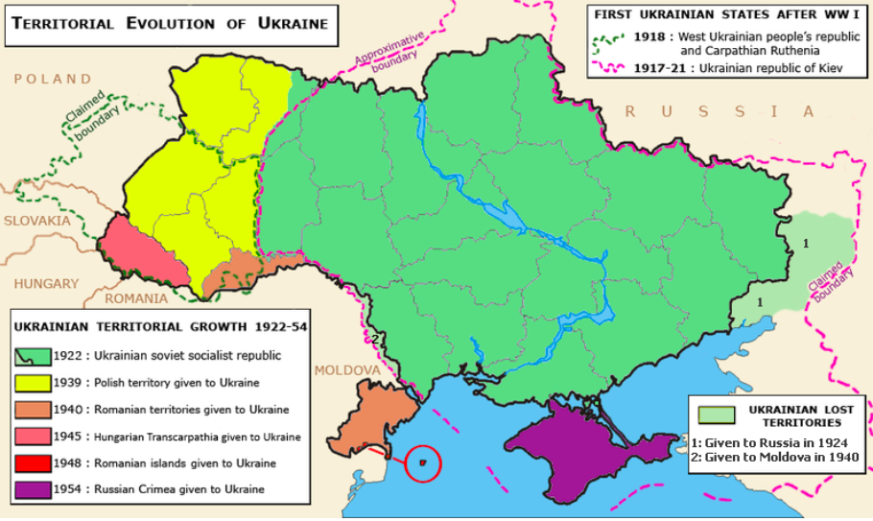

Ukrainian Politics of the 1930s

Members of St. John’s took a lively interest in events in the ancestral homeland, the Ukrainian territories that were at that time divided among the Soviet Union, Poland, Romania, and Czechoslovakia. To the extent that it was possible, they strove to help their co-nationals in Europe in their struggle for a free and independent Ukraine.
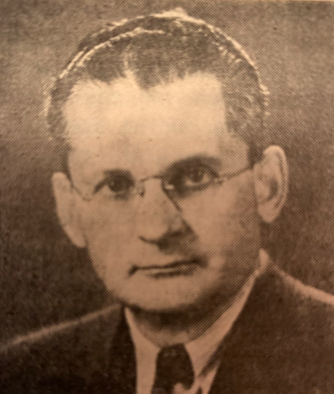

PETER J. LAZAROWICH

Among the leading Ukrainian activists in Canada was a prominent member of St. John’s parish, Peter J. Lazarowich, and it is worth saying a few words about him. In 1903, at the age of three, he arrived in Canada with his parents, who settled in Rosthern, SK. He graduated from the University of Saskatchewan in the spring of 1927, having resided at the Petro Mohyla Institute in Saskatoon since 1916. In that milieu he absorbed all the progressive ideas circulating among the nationalists and forged strong bonds with some of the outstanding leaders of the community, such as the Stechishin brothers and Wasyl Swystun. It happened that in 1927, the Hrushevsky Institute in Edmonton was looking for a new rector, and – on the recommendation of Julian Stechishin – Lazarowich was hired for the position. He remained rector of the institute until 1932, when he left Edmonton to spend two semesters in Prague studying at the Ukrainian Free University. He was a major player in the Ukrainian Self-Reliance League (SUS), founded in 1927 in Edmonton. He contributed a great deal to St. John’s parish. He directed the choir gratis from 1927 to 1947. He served briefly as secretary of the parish’s Ridna Shkola, and his wife taught in the Sunday school. Lazarowich also served on St. John’s board in 1928-32 and on its control committee in 1934-36. He was a delegate from the parish to the important sobor of 1935. His major interventions in Ukrainian politics were accomplished through his work in the Ukrainian Self-Reliance League. He was certainly not alone in this work, but he was an energetic mover and shaker.

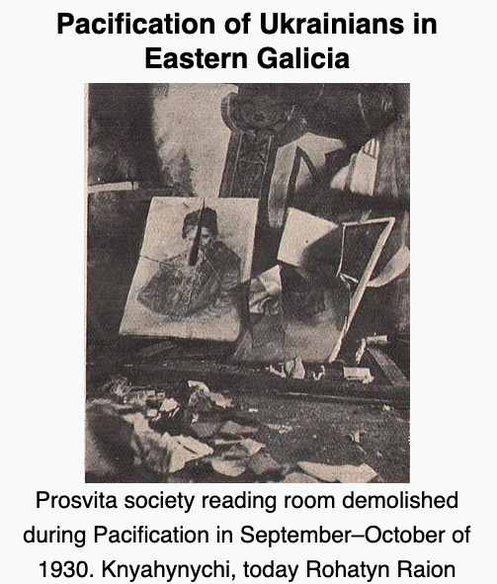
One of the issues that exercised many Ukrainians was the “pacification” of 1930. In response to arson and violence undertaken by youthful members of the Organization of Ukrainian Nationalists (OUN) in Galicia and Volhynia, the Polish government unleashed a brutal campaign against Ukrainian institutions of all sorts – cultural, sporting, political – and Ukrainian leaders of every political stripe. Polish soldiers destroyed Ukrainian buildings and severely beat Ukrainian activists. SUS, together with other Ukrainian organizations, succeeded in bringing these “Polish programs” to the attention of the League of Nations.
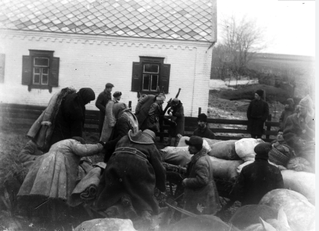
A few years later, SUS reacted to the much more lethal events that were taking place in Ukraine under Soviet rule. At its 1934 congress, held in Saskatchewan and Edmonton, it condemned both the manmade famine that took millions of lives in Soviet Ukraine as well as the mass arrests and murders of Ukrainian intellectuals. A year previously, St. John’s Women’s Society submitted a memorandum and resolutions to the Edmonton Local Council of Women to inform them of the famine in Ukraine.

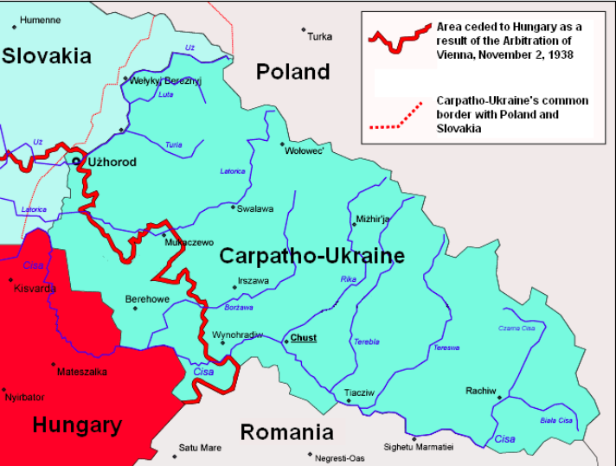

In 1938, as international rivalries were inching the world to war, there emerged for several months an autonomous state, Carpatho-Ukraine, carved out of the former Czechoslovakia. SUS welcomed this development at its 1938 congress, hoping that it would form the nucleus of a larger and completely independent Ukrainian state. On 7 November 1938 in Edmonton SUS initiated the Committee to Aid Carpatho-Ukraine, which a number of other organizations also joined. The treasurer and a member of the board was Fr. Yeronim Hrycyna, the pastor of St. John’s at the time.

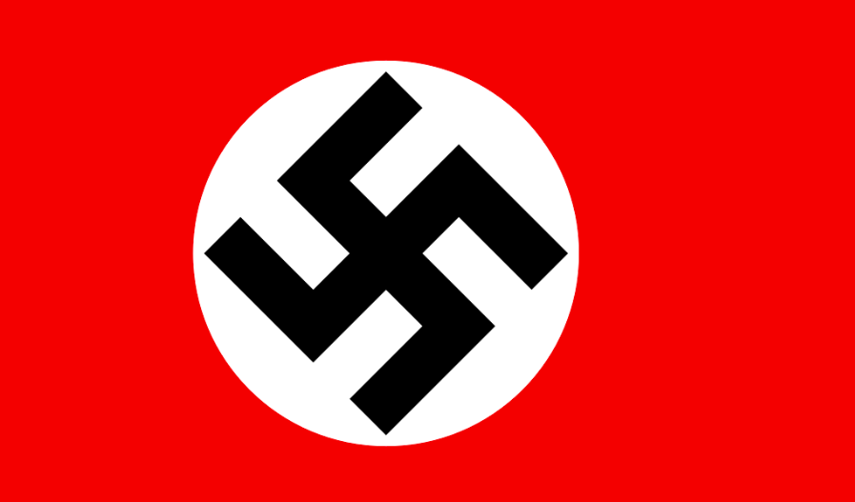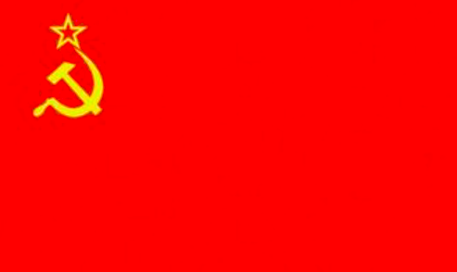

SUS fought hard against groups within the Ukrainian community that were sympathetic to Nazi Germany. At its 1939 congress, held in December after war had already broken out, it passed a resolution stating: “Ukrainian Canadians do not see perspectives for the liberation of the Ukrainian nation in Europe either by communist Russia or by Nazi Germany, because both of these states worship brute force as their god, and the congress condemns equally both of these states....The congress expresses its profound conviction that only the victory of Great Britain and France, the victory of the ideologies which they profess, of the ideals of democracy and peaceful resolution of quarrels among nations, the appropriate reconstruction of Europe and union with other freedom-loving nations, as equals with equals, will give the Ukrainian nation in Europe the ability to acquire and guarantee that freedom, for which it has struggled for hundreds of years.”

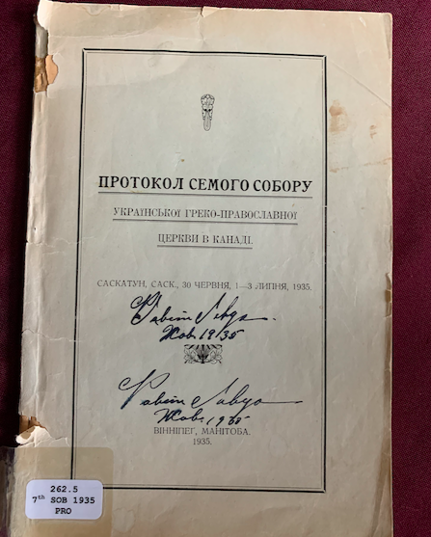

The Sobor of 1935

The Seventh Sobor of the Ukrainian Greek-Orthodox Church of Canada took place in Saskatoon from 30 June to 3 July 1935. Although this was the seventh council of the church, it was the first to which St. John’s parish sent delegates. And what a sobor it was! Sessions lasted until almost 1:00 in the morning. Hot passions and intemperate language – even tears – marked the course of the debates.

FATHER YERONIM HRYCYNA

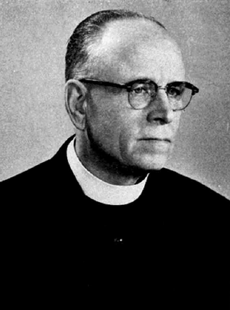

St. John’s chose as its delegates Peter Lazarowich and Andrew Batiuk. The pastor, Fr. Hrycyna, also attended the sobor. In the week before the sobor, the board held a special meeting to instruct the delegates about the positions they were to take in Saskatoon.

WASYL SWYSTUN

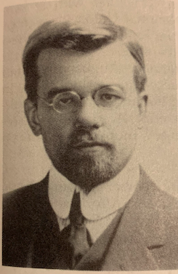
The delegates knew they would be entering a maelstrom. In the several months preceding the sobor, a toxic debate had been raging among long-time Orthodox activist Wasyl Swystun, the head of the consistory Fr. Semen Sawchuk, and Archbishop John (Theodorovich).
FATHER SEMEN SAWCHUK

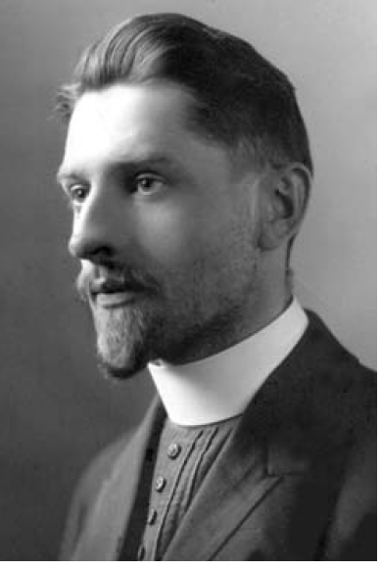

ARCHBISHOP JOHN (THEODOROVICH)

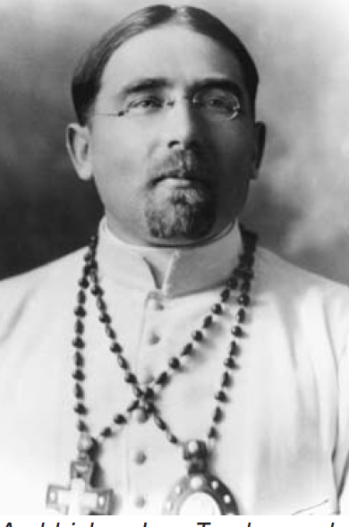

The debate was launched by Swystun, who published a pamphlet that portrayed both Fr. Sawchuk and the archbishop as traitors to the Ukrainian Orthodox church. Certainly personality issues colored this dispute, but important matters of principle were also at stake. Perhaps the key matters of contention can be reduced to two: 1) whether Archbishop John should accept a correction to his episcopal ordination and 2) whether the Ukrainian Greek-Orthodox Church of Canada was part of, and therefore accepted the canons of, the Ukrainian Autocephalous Orthodox Church in Soviet Ukraine.

At the root of both issues was the fact that the Ukrainian Autocephalous church in Ukraine had been unable to attract to its ranks a bishop from among the existing Orthodox episcopate and was also unable to convince any Orthodox bishop to ordain a bishop for it. So it resorted to ordaining an episcopate by what was called the Alexandrian method: at the founding council of the Autocephalous church, held in Kyiv in 1921, the assembled clergy and laity laid hands on the priest Vasyl Lypkivsky and proclaimed him a bishop, in fact the metropolitan of the new church. This Alexandrian ordination was not recognized by other Orthodox churches, and thus the Ukrainian church was not in eucharistic communion with them. Neither would Catholics recognize this form of episcopal ordination.
The head of the church in Canada, Archbishop John, had been ordained a bishop by Metropolitan Vasyl and another Autocephalous bishop, so his ordination was also not recognized by the other Orthodox or the Catholics. Even though both Archbishop John and the Ukrainian Orthodox church in Canada affirmed the validity of the Alexandrian ordination, the archbishop by the early 1930s was negotiating with the Ecumenical Patriarch of Constantinople to “correct” his ordination so that he would be recognized as valid by others. Partly this was because the archbishop sought to end the isolation of the Ukrainian Orthodox from other Orthodox churches in North America. But there was also a more specific trigger for his negotiations with Constantinople. Archbishop John was not only the head of the Ukrainian Orthodox church in Canada, but also of the Ukrainian Orthodox church in the United States. In the late 1920s and early 1930s, a group of Ukrainian Catholic priests, led by Joseph Zuk, broke with their bishop. Although they negotiated with Archbishop John to enter his American church, they considered his Alexandrian ordination invalid and were reluctant to join with him. It was at this juncture that Archbishop John began to seek a rectification of his ordination from Constantinople.
And it was this that led Swystun to charge him with treason to the Ukrainian Orthodox church and to seek his removal. Instead of a “correction” from the patriarch, Swystun wanted the Canadian church either to receive a new bishop from the Autocephalous church in Ukraine or to ordain a new bishop by the Alexandrian method. What the Seventh Sobor of the Ukrainian Orthodox church in Canada decided in the end was that the archbishop should not pursue a “correction”; that the Alexandrian ordination was a valid, one-time revolutionary response to a revolutionary situation; but that in future the hierarchy of the Canadian church would be ordained by Orthodox bishops whose validity was recognized by the rest of the Orthodox world. This outcome essentially reflected the view of the head of the consistory, Fr. Sawchuk. The delegates from St. John’s were completely in agreement with him.
Closely connected to the issue of the Alexandrian ordination was that of relations between the Autocephalous church in Ukraine and the Canadian church. Swystun charged Fr. Sawchuk and the archbishop with breaking the connection between the churches. The trigger here was the defection of two priests from the Ukrainian Catholic church in America to the Ukrainian Orthodox church under Joseph Zuk’s leadership. The priests had been suspended by their Catholic bishop for marrying after ordination. Fr. Sawchuk published an article in March 1935 in Ukrains’kyi holos supporting the Catholic suspension and criticizing the acceptance of the two priests by the Zukites. Fr. Sawchuk reiterated the standard Orthodox position that married men could be ordained to the priesthood, but that priests, once ordained, could not marry. Swystun attacked this position, arguing that the resolutions of the 1921 council of the Autocephalous church had eliminated this prohibition as part of its modernization of disciplinary canons. Swystun insisted that the church in Canada was but a branch of the Autocephalous church in Ukraine and hence had to follow its canonical regulations. But the Seventh Sobor did not agree. Part of the problem was that the Autocephalous church had been severely repressed by the Soviet authorities, beginning in 1930. They forced Metropolitan Vasyl to resign and then exiled his successor. They also arrested numerous lay activists of the church. Two years after the Seventh Sobor, in 1937, the Soviets totally destroyed the Autocephalous church as an institution in Ukraine. Swystun had thought the Soviets would ease up on the Autocephalous church, but he misunderstood completely the direction in which the Soviet Union was heading. It was the eve of Stalin’s Great Terror.
The Seventh Sobor censured Swystun but did not exclude him from the church. Swystun briefly repented at the sobor, but shortly thereafter returned to his polemics against Fr. Sawchuk and the archbishop. He had a base of support in his own parish, St. Mary the Protectress Cathedral in Winnipeg. The pastor there was Fr. Peter Mayevsky, who had actually served as a priest of the Autocephalous church in Ukraine. Fr. Mayevsky had supported Swystun at the sobor and also briefly repented. The archbishop had taken pity on him and refrained from seeking a motion of censure against him.
Shortly after the sobor, Swystun renewed his polemics, and this became the subject of a special meeting of St. John’s parish. On 1 September 1935 the delegates and Fr. Hrycyna reported to the parishioners about the stormy events of the Seventh Sobor. At the end of this meeting, the parish passed five resolutions. One of them endorsed the decisions of the sobor concerning the main issues in dispute: “The Ukrainian Orthodox Community of St. John’s in Edmonton is in solidarity with the decisions of this sobor as to relations with the patriarch and the ‘Zukites.’” The other four resolutions all concerned Swystun’s activities since the sobor.
One of the resolutions affirmed that the Seventh Sobor was “correct, legal, and legally binding.” This was not a pro forma statement. It was a direct response to Swystun, who after the sobor called it “illegal, irregular, and invalid.” Another resolution stated: “Mr. Swystun’s opposition to the very sobor of the Ukrainian Orthodox Church in Canada and to the church’s leadership is considered unjustified and damaging to our church, and his demand to convoke another sobor, as if the Seventh Sobor of the Ukrainian Orthodox Church of Canada were illegal and invalid, is without foundation and not justified by anything.” Another resolution condemned the newspaper that Swystun founded after the sobor, Ridna tserkva (Native Church). Swystun published it, the resolution said, “to the ruin of our church.” And the last resolution condemned the organization he founded after the sobor, the Ukrainian Church Defence Brotherhood (in Ukrainian: Bratstvo oborony ridnoi tserkvy). The resolution pointed out that the brotherhood existed “outside the framework of the charter and statute of our church.”
St. John’s emerged from the crisis of the sobor firmly planted in the church mainstream. The results for the church as a whole were rather mixed. On the positive side, some outstanding uncertainties were clarified, and the Ukrainian Canadian church moved a wee bit closer to the practices of other Orthodox churches. But there was considerable damage. Wasyl Swystun was lost to the church. This man had been one of its founders, travelling great distances in the Prairies to promote it among Ukrainian settlements. He had been so identified with the Orthodox movement that its opponents labeled the Orthodox “Swystunites” (svystunivtsi in Ukrainian). Unanchored after the Seventh Sobor, Swystun went off to join the extreme nationalists of the Ukrainian National Federation (perhaps better known by its Ukrainian acronym UNO). Later he made a political U-turn and joined the pro-Soviet “progressives.” He maintained a law firm that specialized in inheritance cases of Soviet citizens. The church not only lost Swystun, but his parish, St. Mary the Protectress in Winnipeg. Fr. Mayevsky was suspended not long after the Seventh Sobor. He chose to ignore the suspension and continued serving as pastor. The break with the Ukrainian Greek-Orthodox Church of Canada was to last until the late 1940s.

Sight and Sound

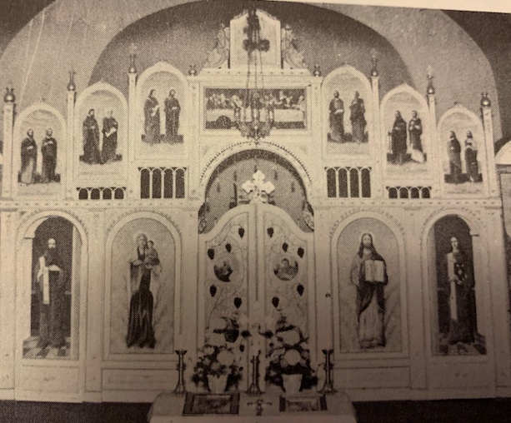
Once the economic depression began to lift, St. John’s undertook two important projects. One was the installation of an iconostasis in the church. The parish had been talking about an iconostasis since 1933, but postponed it until better times, which came in 1937. The framework of the iconostasis was carved by Paul Kipran of Winnipeg. He charged $450. The icons on the iconostasis were painted by Dr. Leo Snaychuk. Snaychuk was known in the Edmonton community for painting the sets of Ukrainian theatrical productions at the Hrushevsky Institute. Prior to painting the iconostasis for St. John’s, Snaychuk had painted the iconostasis of Ss. Peter and Paul Ukrainian Orthodox church in Brooksby, SK; he was also one of the artists that painted St. Onuphrius Ukrainian Catholic church in Smoky Lake (now in the Canadian Museum of History in Gatineau, PQ). He charged $345 for painting St. John’s iconostasis.

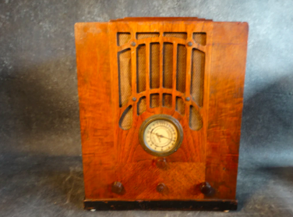

In 1935 St. John’s began to broadcast the liturgy over the radio on station CFRN. The broadcasts were intermittent, only several times a year, but very much welcomed in the many rural settlements that were not able to hold in-person services every Sunday. The Ukrainians on the farms contributed to the costs of the broadcast and advertising, and Peter Svarich in Vegreville collected their donations. St. John’s received letters from the countryside expressing listeners’ satisfaction. A man from Holden, AB, wrote: “…What a great service you provide to our creator, our church, and our people with your liturgies! And when one adds to that that we live in an amalgam with different people with different religions and social classes, then what you do is a priceless treasure, generally speaking, for the Ukrainian people” (13 June 1935). Four days later, he wrote again: “If you could only see the result of your work among the Ukrainian Greek Catholics.” Indeed, Ukrainian Catholics were also listening to the services. It was reported to St. John’s that even one of the Ukrainian Catholic priests was listening. A Ukrainian Catholic wrote directly to the parish: “Even though I am a Catholic, I felt proud of the Ukrainian ritual, because even among us Catholics we have the same ritual” (3 March 1935). He remarked that an Englishman had also listened to the service. In short, the radio broadcasts were a great success and a real service to rural Ukrainian communities. They also burnished the reputation of the Ukrainian Orthodox church among outsiders.

World War II

World War II commenced in September 1939. We do not possess an accurate list of all the men from the parish who served, but we know that quite a few did. The writer Illia Kiriak compiled a list, probably incomplete, of members and members’ sons who enlisted in the armed forces by the end of October 1942.

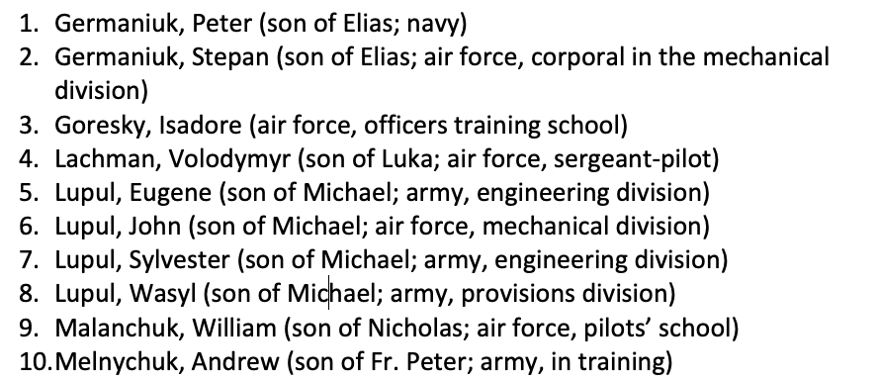
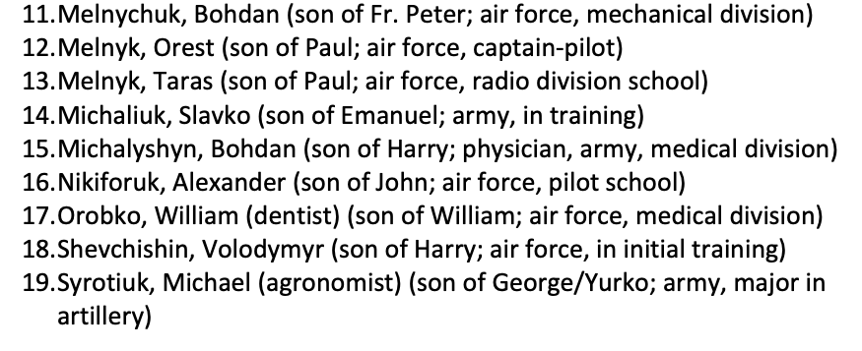
In the spring of 1942, the parish council passed a resolution that all parishioners in the armed forces were to be considered fully enfranchised members of the parish even if they did not pay their dues.
On the home front, the women of the parish were impressively energetic in supporting the war effort. The Women’s Society (Ukrainian Ladies’ Aid) struck a Red Cross Committee and a War Committee, largely under the leadership of Doris Yanda and her right-hand woman Emma Verchomin. What these women did!

DORIS YANDA

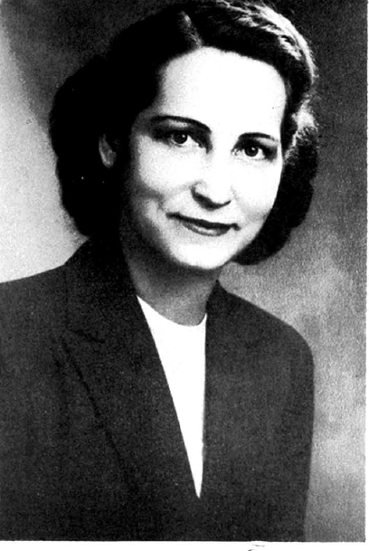

EMMA VERCHOMIN

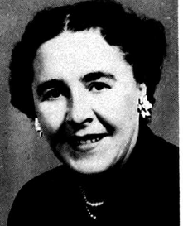

They mainly worked with the Red Cross. The Red Cross would ask the women to sew certain items, and they did – white doctors’ gowns, pajamas, dresses, towels, pillow cases, sheets, and scarves. They also knitted clothing for the soldiers – sweaters, gloves, and socks. They held teas and sold tags on Tag Days to raise money for the Red Cross. Our women contributed to the purchase of an ambulance. They disinfected equipment at the blood donor clinic. They helped the Red Cross with packing parcels for soldiers stationed in England. They were active in Edmonton’s Superfluity Shop. The Superfluity Shops in Canada during World War II were like our modern day thrift shops, except that the proceeds went to the Red Cross and the war effort more generally. The Women’s Society delegated members to volunteer at the Superfluity Shop, and also donated numerous items to the shop, especially Ukrainian baked goods, jars of preserved fruit and pickles, fresh vegetables, and used clothing. In 1942 the women of St. John’s parish donated about a hundred jars of preserves to the Superfluity Shop.

But the Red Cross was not the only beneficiary of the women’s work. In August 1940 the Canadian government launched the National Registration to identify human resources for the war effort; the women of St. John’s were active in registering citizens. They sold war bonds and War Savings Stamps. They made jars of jam and sent them off to children in beleaguered Britain. They collected used items and sorted them for the National Salvage Campaign, much of what they collected ending up in England.

They had a particular devotion to soldiers of Ukrainian heritage. They sent hundreds of parcels with food and cigarettes to the Ukrainian military canteen in London. They hosted Ukrainian soldiers in their own homes too, some local, but others from elsewhere in Canada or from America. The soldiers from far away, who knew no one else in Edmonton, were particularly appreciative of the warm hearts, hot meals, and homemade baked goods.

