Splendor and Beauty
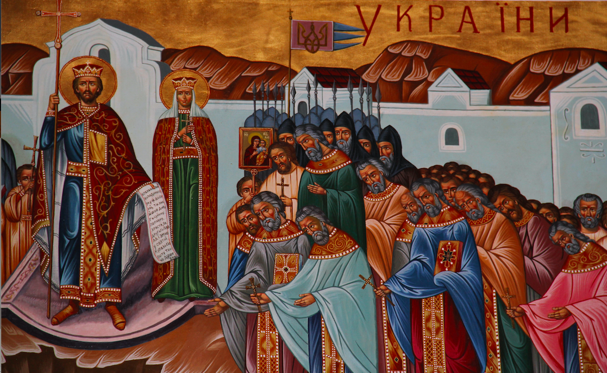

According to the Rus’ Primary Chronicle, Grand Prince Volodymyr of Kyiv sent out emissaries to investigate what religion pagan Rus’ should adopt. The emissaries travelled, among other places, to Constantinople. They reported back to their ruler:

…The Greeks took us to the edifices where they worship their God, and we knew not whether we were in heaven or on earth. For on earth there is no such splendor or such beauty, and we are at a loss how to describe it. We only know that God dwells there among men, and their service is fairer than the ceremonies of other nations. For we cannot forget that beauty.

If the emissaries had been not sent to Constantinople in 987 and instead to St. John’s Cathedral in 2023, it is unlikely that their report would have been substantially different.

The New Iconostasis
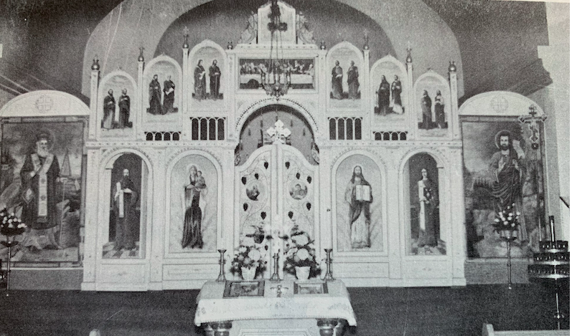

For the first twenty years, from 1952 to 1972, the present church made use of the iconostasis from the old church, the one painted by Dr. Leo Snaychuk. Because the old church was smaller than the new one, Snaychuk’s iconostasis had to be expanded by the addition of two large icons of St. Nicholas on the left and St. John the Baptist on the right. This was a makeshift arrangement. Metropolitan Ilarion at least twice, in 1957 and again in 1958, urged the parish to install a new iconostasis and to repaint the church interior. But the parish, at the advice of Fr. Yeronim Hrycyna, postponed these tasks to concentrate their efforts and funds on the building of a church hall, since a venue was needed for children to attend classes.

It was only in 1968 that the parish felt comfortable enough in its financial situation to decide upon installing a new iconostasis. Heading up the project were William Hawrelak, who was between terms as mayor of Edmonton, and the two pastors, Alexander Chomiak and Dmytro Luchak. They engaged Wadym Dobrolige to prepare a design. He made a model of the iconostasis and later drew up plans and specifications. The board and Archbishop Andrew approved the plans and hired Dobrolige to begin work on the iconostasis. He worked on it from 1969 to 1972.
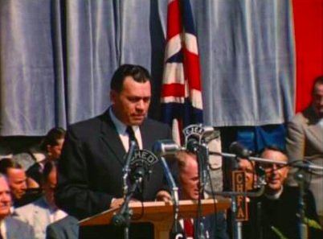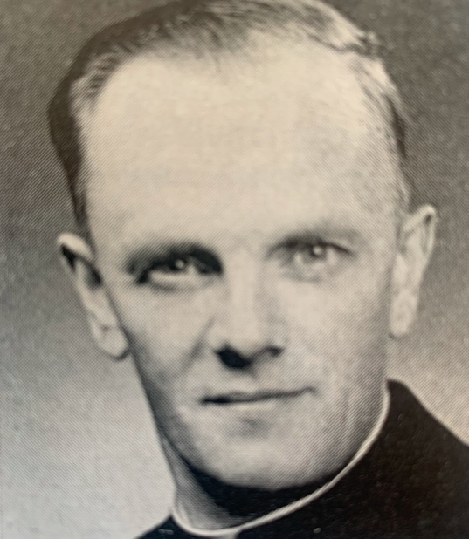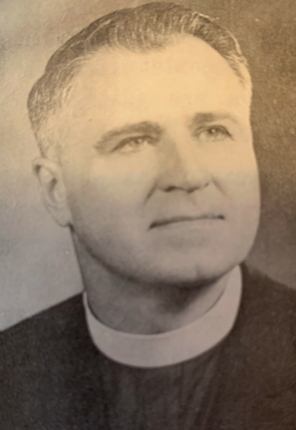
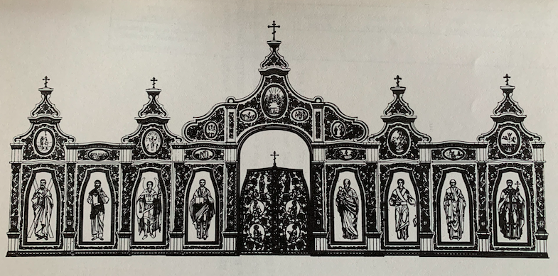

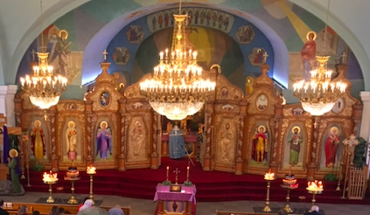
The new iconostasis was designed in Cossack baroque style, with a layout soaked in tradition. The entire ensemble is a masterpiece of Ukrainian sacral art, instilling in the worshiper a prayerful attitude. The life-size figures of the Savior, his Mother, and the saints help us understand how Volodymyr’s emissaries felt in the churches of Constantinople: “We knew not whether we were in heaven or on earth.”

Stained Glass Windows in the Nave
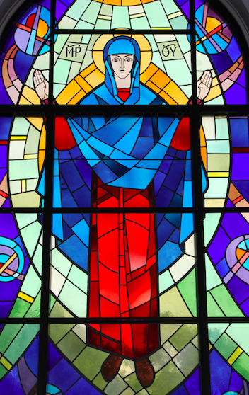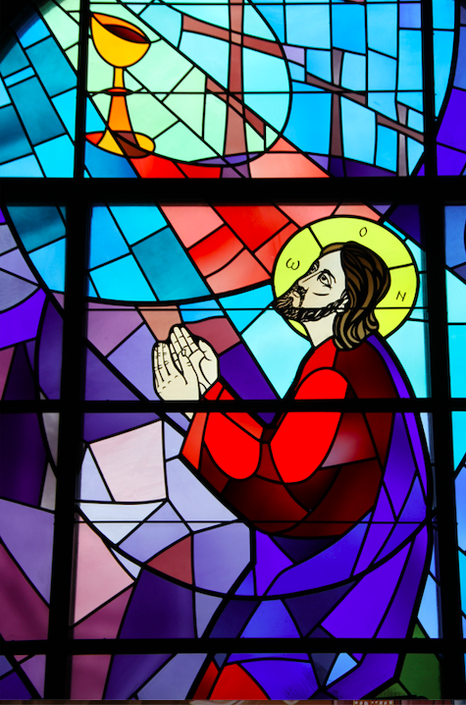

St. John’s has also been blessed by another impressive sacral ensemble, the stained glass windows that flank the nave. They were installed in 1988, the creation of Winnipeg artist Roman Kowal. Born in a Ukrainian village now in Poland, Kowal studied in Lviv and Munich, and came to Canada in 1948. According to the Internet Encyclopedia of Ukraine, he was best known for his stained glass windows and mosaics that “incorporated abstract design into a neo-Byzantine form.”

Kowal’s windows in St. John are arranged so that the ones referring to the life of the Savior are on the right (south) side of the church, while those referring to the Mother of God are on the left (north side). Kowal was also the creator of the mosaics at the entrance to the cathedral.

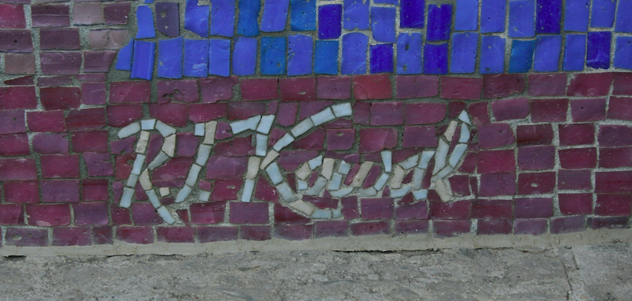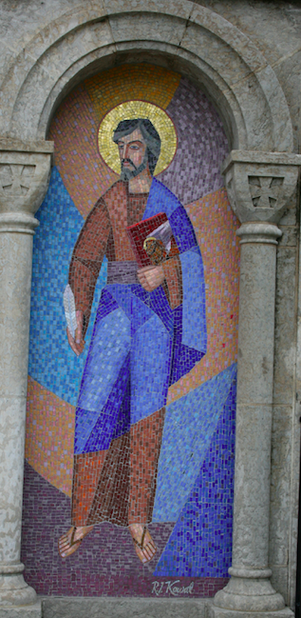

The Chandelier

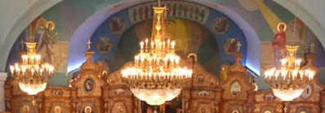

A Baptist visitor to our church wrote: “The elegant main chandelier which was imported from Portugal and installed in 2012, contains fine gold detail that couples with Swarovski crystals to dazzle within the room. This piece adds an extra sense of royalty and splendour to the space.” The saga of this chandelier started in 2005, when the previous chandelier was being cleaned. It turned out that the old chandelier was simply falling apart. Trying to find a replacement that was adequate to the large space of the cathedral was a great challenge, which was only overcome in July 2012, when the new chandelier was installed. A few months later, two smaller chandeliers were also installed. The cost of the whole project, before GST, was $118,000.

One could talk much longer about other artistic treasures that adorn the cathedral. In fact, the cathedral well deserves a guidebook of its own.

The Women
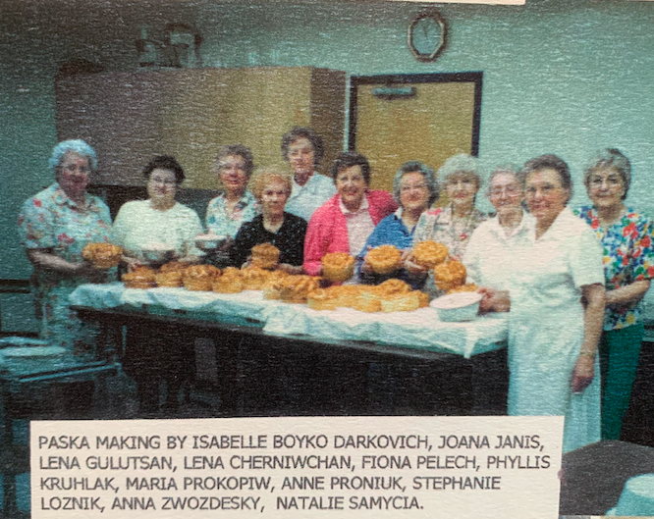

It is hard to establish when the first woman was elected to the parish board, but they certainly began to appear by the mid-1950s. The jubilee book marking the fortieth anniversary of the parish in 1963 recorded that the parish’s branch of the Ukrainian Women’s Association had, since its founding, donated $157,955 to the parish! But this would prove to be just the tip of the iceberg. In 1994 a major renovation project was completed that included connecting the church to the auditorium and expanding and refurbishing the kitchen. The parish was developing a catering operation that would bring in hundreds of more thousands of dollars over the following years.

But the women also had fun.
It is worthwhile to quote a substantial passage from the Historic Highlights of the Ukrainian Women’s Association of Canada, St. John’s Cathedral Branch 1976-2001. It concerns the Fall Balls that were hosted in what was then the newly built cultural center:

When the idea of a Fall Ball first originated in 1965, it was planned as a special night for the members of the branch. The initiator of the ball was Natalka Faryna who was convener of the first ball together with Valentina Dobrolige. It was not until the fourth ball that a complete change of format took place. This occurred in order to keep up the interest and have people returning year after year. The fourth ball in a sense set a precedent for all other balls to come, as it was found that a greater interest was created by choosing a different country or theme and making sure the décor, food, entertainment, music, and dress, were authentic. It was decided that every fifth year the theme would be Ukrainian.

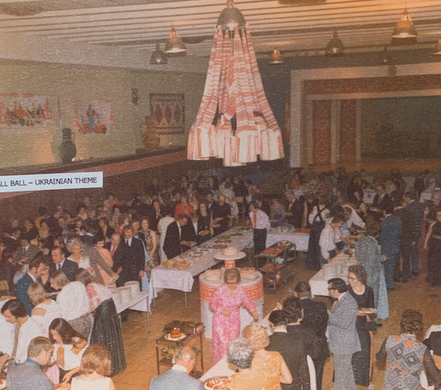
It is unfortunate that time and space does not allow us to describe all the Fall Balls as they were all very beautiful and very innovative creations. Some of the themes were: Centennial Ball, Hawaiian, Ukrainian, Golden Dragon, Hansel and Gretel, A Night in Venice, French, Hollywood, and many others. This tradition continued for approximately thirty years. Each and every one of these balls was organized by capable members who were inspired by the theme to make a memorable evening for the guests.

Credit for the success of the balls for the first ten years must be given to a very talented and artistic individual, the late Wadym Dobrolige. Enough cannot be said of how unselfishly he gave of his time, efforts and talents to our organization as artistic designer of our balls. Every year he spent many months doing research, trying to capture the essence of each particular country before preparing decorations such as silk screening of tablecloths, runners, banners, painting of murals and planning special lighting effects. Some of the decorations were later sold and the proceeds went to Soyuz. Even after giving so much of himself he still insisted on buying tickets to attend the ball. Mr. Dobrolige played an important role in the history of the Fall Ball and this must be recognized.

More recently, the women of UWAC commissioned a legacy mosaic celebrating the parish’s centennial. The mosaics were created by Theodora Harasymiw and are mounted in the cultural center. They celebrate “Our Heritage: The Past, the Present, and the Future.”

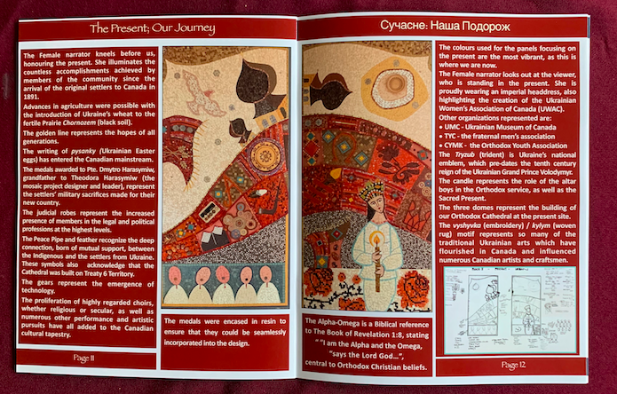

The Russian Primary Chronicle: Laurentian Text, trans. and ed. Samuel Hazzard Cross and Olgerd P. Sherbowitz-Wetzor (Cambridge, MA: The Mediaeval Academy of America, 1973), 111.
Peyton Rockel, “Through the Eyes of a Baptist Christian,” Cathedral Connection, 22, no. 1 (April 2018): 19.

