The English Language
Aside from migrations, there was another sociological change underway: a deteriorating knowledge of the Ukrainian language among the youth and the increasing employment of English in parish life. The first symptom of this change was a motion put before the parish board on 12 July 1956: “To write to the consistory and explain that we absolutely need a priest who has a perfect command of English, because circumstances in Edmonton require it.” By the next year the youth brotherhood in the parish was conducting its meetings in English. Again, at an extraordinary board meeting on 19 August 1959, Lena Budnick raised the issue of a priest “who has a good command of the English language so as to be more accessible to the youth and children.”

A special committee was struck in the parish in 1960 to deal with the language question. The committee consisted of John Decore, who served as chair, Kost Telychko, and Steve Cybak. Here is what they proposed: that two liturgies be held every Sunday, one with a sermon in Ukrainian, the other with the sermon in English; that the liturgy be celebrated in English, especially for mixed marriages; that Sunday school lessons be conducted partially in English; that the liturgy be shortened; that the church’s periodical, Visnyk, publish some articles in English; and that liturgies be celebrated on Latin Christmas and Easter. Only some of these proposals were implemented. In that same year the parish purchased bilingual prayer books to place in the pews.

The change in the language used in the parish is well captured by this fact: the fiftieth anniversary booklet of the parish (1973) was entirely in Ukrainian, the seventy-fifth (1998) was primarily in English.

Eventually, the language question was solved by a division of labor among the various parishes. St. Anthony’s, for example, which is the youngest of the Ukrainian Orthodox parishes in Edmonton, uses a lot of English, in the liturgy and in the sermons, while St. John’s has been the parish of choice for those who prefer to worship in Ukrainian. St. John’s did experiment with English services once a month, but attendance was low, and the all-English services were discontinued in 2020. Since then, parish services employed a mixture of Ukrainian and English, with Ukrainian predominating.

Lesia/Alice Chumer, Choir Director, 1976-2020

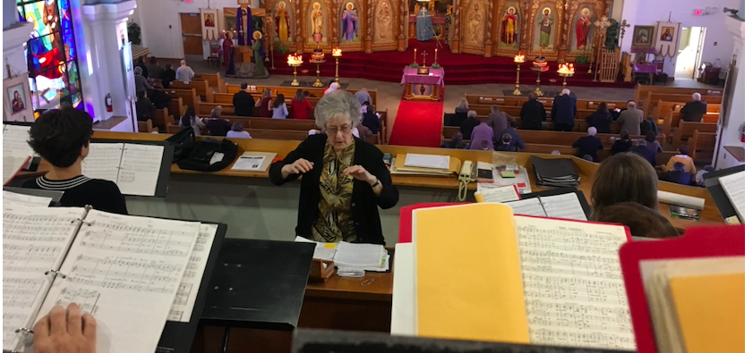

Lesia Chumer directed St. John’s choir for forty-four years. No other choir director, no priest, and no cantor served the parish for such a long span of time. She took over the choir in November 1976, when the previous director, Roman Soltykewich, died of a heart attack. When she retired as director in October 2020, she was replaced by Roman Soltykewich’s son, Orest Soltykevych.

Lesia was raised in Boyle, AB, but like so many rural and small-town Ukrainians, her family moved to Edmonton in 1948. At the age of fourteen Lesia was encouraged to join St. John’s choir by the director, who at that time was Alexander Yefymchuk.

Later, as director of the choir herself, she developed – as all directors do – her own style. She amassed a huge library of liturgical music, and the choir would generally learn four or so versions of each piece (“Our Fathers,” “Cherubic Hymns,” etc.). On Sundays, as each part of the liturgy progressed, she would flip through her binder and pick one of the versions that she had taught the choir. No one knew in advance exactly what they would be singing. Sometimes, however, she would pick a piece that the choir had never practiced or had sung only in the rather distant past. One could always tell if it was one of these sight-reading Sundays because a mischievous smile would cross her lips before she announced her choice of what was to be sung. She held choir practices for two hours most Wednesday evenings during the year, except for summertime.

The Pandemic Lockdown
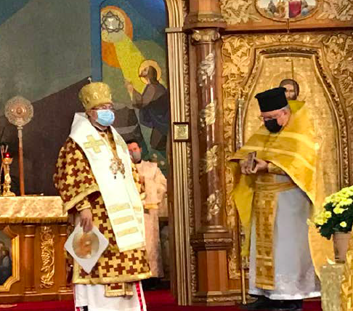

In early 2020 a global pandemic broke out, caused by a coronavirus, Covid-19. In response, governments closed down venues that served as gathering places for the public – restaurants, pubs, stadiums, and churches. St. John’s was able to enjoy weekly liturgies through 15 March 2020, but after that there was a hiatus during which no services at all were allowed, both by government decree and by the decision of Metropolitan Yurij (Kalistchuk). Liturgies were still celebrated, but the congregation was absent. Instead, as of 22 March, St. John’s began to livestream the liturgy. Later, on 12 July, as the lockdown was partially relaxed, it was possible to attend services in a limited way. Some pews were blocked off with tape to insure social distancing. Members who wanted to attend had to sign up in advance, and there was a cap of 15 percent of capacity (thus forty-five participants). The Eucharist was taken not from the spoon; instead a morsel of the consecrated bread, tinctured with the consecrated wine, was placed on a napkin to be consumed by the communicant. Choral singing was also banned during the lockdown, so the choir was completely supplanted by the cantor, Fedir Gotsaliuk.

Aside from the impact on liturgical life, the lockdown affected the finances of the parish. St. John’s had been relying very much for funding on a successful catering operation; but no events were allowed during the lockdown. There was no collection when there was no liturgy, and later when a restricted number of parishioners were allowed to attend, the collection baskets were not as full as they would normally be. The parish had to lay off staff temporarily. But government subsidies and generous donations by parishioners allowed St. John’s to make use of the lockdown to upgrade and renovate facilities, including bringing up to code the alarm systems.

A Ukrainian proverb has it that there is no evil from which good will not come (Нема такого злого, щоб на добре не вийшло). Everything has by now returned to normal in the parish: the choir is singing every Sunday, communion is taken in the traditional manner, and there are no restrictions on attendance. But one result of the lockdown remains: the streaming of the liturgy every Sunday on YouTube. For an aging parish, this is a valuable instrument.

War
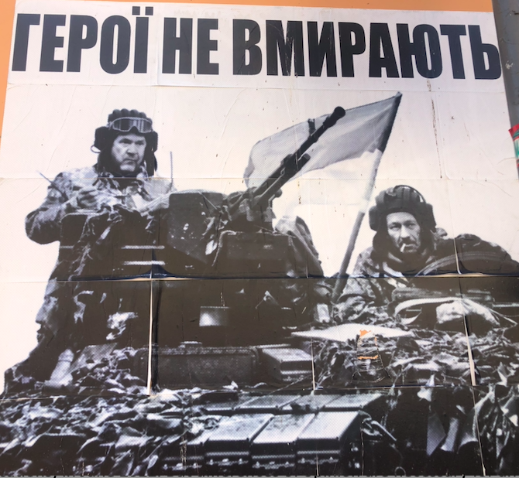
Ukraine has been at war with Russia since 2014, but the war dramatically escalated when Russia launched a full-scale invasion on 24 February 2022. Since then, the parish has been praying for the repulsion of Russian forces and for peace at every liturgy. A large number of Ukrainians were displaced from their homes as a result of the war and fled, with over eight million in Europe as of spring 2023. Over 650,000 have come to Canada as well, about 7000 of whom are in Edmonton. This has had an effect on our parish, since now a sizable portion of the congregation every Sunday consists of these refugees. The parish has welcomed them and supported them in various ways. It is quite possible that this new group will reinvigorate, and even reinvent, our community.

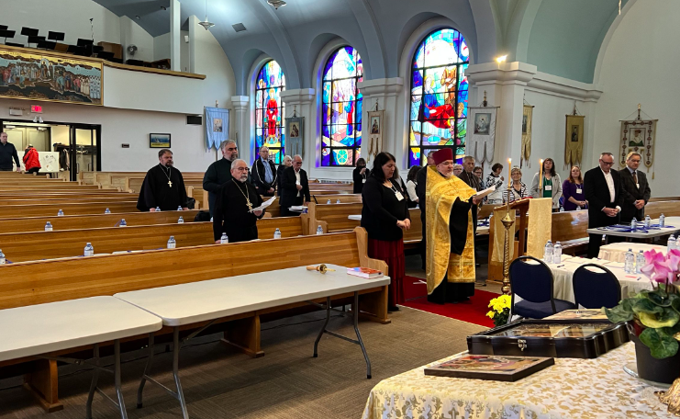

The Congregation at One Hundred
At a hundred years of age, St. John’s parish, like any group of people, has some differences and divisions regarding the way forward for our congregation and for our church in Canada as a whole. The latter division was particularly evident at the twenty-fourth sobor held (remotely in different locations) in June 2022. But differences of opinion are necessary for any organization to make progress, and they serve as an indication of health – when people are concerned about the future, they are not envisioning the termination of their activities.
Overall, if one were to pick one word to describe the atmosphere in St. John’s parish at the end of a centenary of existence, that word would be “friendly.” Much of the credit for this must be ascribed to the gentle leadership of our former pastor, Fr. Stephen Semotiuk, who served this parish for thirty years before his retirement in 2022. The outgoing, pleasant manners of our president, Marshall Kachmar, and of our vice-president, Gerald Kruhlak, contribute to the neighborly atmosphere. And so does the handshake and smile that our greeter, George Zaharia, bestows on everyone entering the church. He is backed up at the vestibule by June Kachmar.

It is hard to think of Fr. Cornell Zubritsky as the new dean of our parish, since he has been assigned to St. John’s since 2008 and has always played a large part in parish life. I think most of us feel that the parish is in safe hands, the hands of someone who sees a path forward. Finally, the life of the parish is hardly imaginable without the dedicated men and women who serve as volunteers.

The parish now has a long history, and more of that history is being made.

