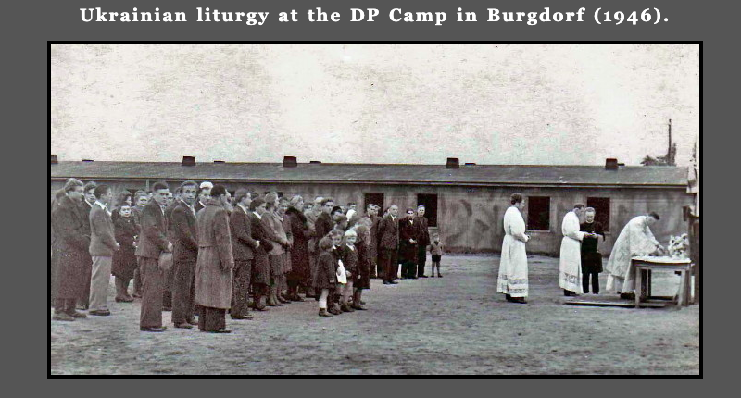

Postwar Migrants
When the war was over, the women transformed their War Committee into a Postwar Committee. Its primary function was to help the two hundred thousand Ukrainians who ended up in displaced persons camps after the fighting was over. The Postwar Committee sent them hundreds of dollars worth of comestibles and hundreds of pounds of clothing. And when the displaced persons arrived in Edmonton, the women helped them fill out documentation and find accommodation and employment.

Archbishop Metropolitan
Mstyslav (Skrypnyk) Illarion (Ohiienko)

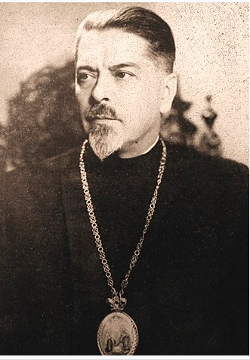v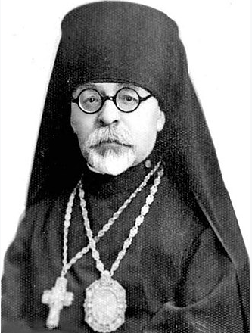

The newcomers, especially those from Bukovina and Volhynia, added to the membership of the parish and of the Ukrainian Greek Orthodox Church of Canada as a whole. The church as a whole gained a new hierarchy of highly educated and prestigious bishops from among the new immigrants. It is enough to mention that the church was headed by Archbishop Mstyslav (Skrypnyk) in 1947-50 and then by Metropolitan Ilarion (Ohiienko) in 1951-72. The former, who was the nephew of the Ukrainian revolutionary leader Symon Petliura, had been a senator in the Polish parliament before ordination; the latter had been a professor and prominent expert in Ukrainian philology.

St. John’s Cathedral Choir under the direction of Yuriy Bilashevych

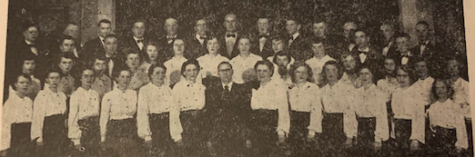

The parish also gained some prominent and talented individuals. It deliberately headhunted among the displaced persons to find a new choir director. The conductor they settled upon was Yuriy Bilashevych. He had been born into a priestly family in Lutsk, in Volhynia. He studied at the conservatory in Kyiv, joined the opera, and later founded a choir under his direction. Before coming to Edmonton, he organized a choir in the American zone of occupation that toured twenty-two displaced persons’ camps. The parish paid him well, $175 a month, which was the same as the pastor was paid. Maestro Bilashevych certainly earned his keep. He took the choir on concert tours in the Ukrainian bloc settlement. A concert in Vegreville in spring 1951 earned $175.65, and another in Two Hills brought in $112.12. He directed the choir from late 1948 until the end of 1951.

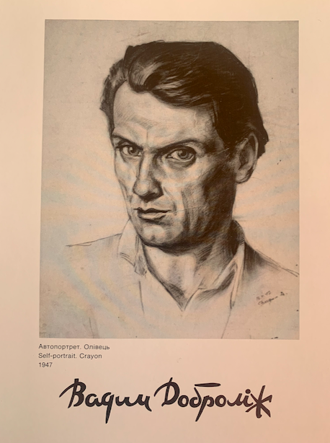
Another important “acquisition” of the parish in this period was the painter Wadym Dobrolige. Born in Nizhyn, near Chernihiv, in 1913, Dobrolige acquired a higher education at the Kyiv State Art Institute , where he worked in the studio of the renowned Ukrainian artist, Fedir Krychevsky. Later he completed his studies at the Academy of Arts in Leningrad. In the Soviet Union he worked primarily in the genre of theater and film set decoration (and he remained a prolific decorator even after he moved to Canada in 1948). He was unable to avoid the Stalinist purges and spent 1935-38 in exile in northern Siberia. Even then he was engaged artistically, helping to decorate the Red Army House in Ussuriisk (on the site of the former Nikolsky Cathedral). During the Nazi occupation, he left the Soviet Union and ended up in Heidenau, Germany, in 1943. It was here that he first began to paint icons. After settling in Edmonton, Dobrolige, in addition to his work as a decorator, painted numerous churches in Alberta. Until his death in 1973, he helped the parish in numerous ways, providing expert advice on artistic matters, designing covers for parish publications, painting stage sets, and eventually, as will be discussed in the next chapter, painting a new iconostasis for the cathedral.
Aside from migrants from Ukraine via the displaced persons camps, the postwar period saw the mass migration of Ukrainians from rural localities like Redwater, Vilna, and Stry to Edmonton. The exodus of the Ukrainian population from rural areas into the city, which was an unstoppable torrent by the late 1950s, was a major demographic change. Up until then, the “colonies,” i.e., the rural bloc settlement, had been the most vibrant center of Ukrainian Canadian life in Alberta. Now Edmonton assumed that role. The minutes of St. John’s annual meeting of 23 June 1949 stated: “In comparison to the past decade we have taken a triple step forward in the growth of membership and income. Our parish has over two hundred families.”

Year | Number of Members
1924 | 12
1930 | 45
1940 | 81
1950 | 364
1960 | 680
1970 | 575
1980 | 577
1990 | 612

Towards a New Church Building
Understandably, the parish began to think of building a new and larger church, one that could accommodate up to six hundred faithful. Fr. Melnychuk, the pastor in the 1940s, saw that a new church was necessary and himself gave $500 to the building fund to prime the pump for donations. The board’s intention to save for a new church was expressed already in October 1942. By 1944 a special committee was set up to examine lots for purchase. Four locations were considered for the new church. One was near Park Memorial Funeral Home (97 St. and 111 Ave.). But this site had some serious drawbacks. For one thing, there was just too much traffic in the area, not just cars but streetcars. (The streetcars were to disappear in 1951, but no one foresaw that in 1944.) The problem with the traffic, aside from the noise, was that it wasn’t safe for the children who would come to church to attend Ukrainian school and Sunday school. It was also thought inappropriate to locate the church so close to a funeral establishment. Moreover, this site would not allow the altar to face east, as prescribed by the canons of the Orthodox church.
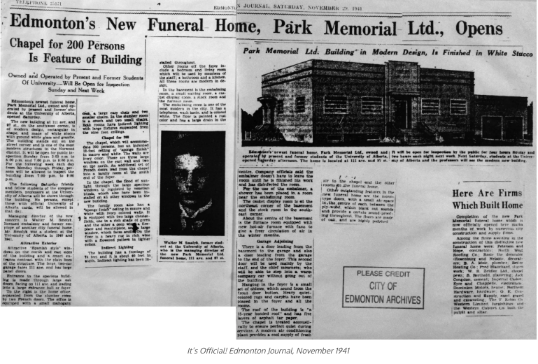

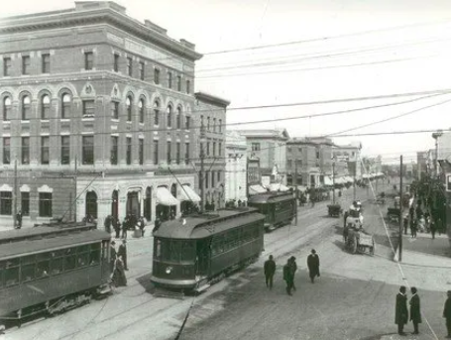

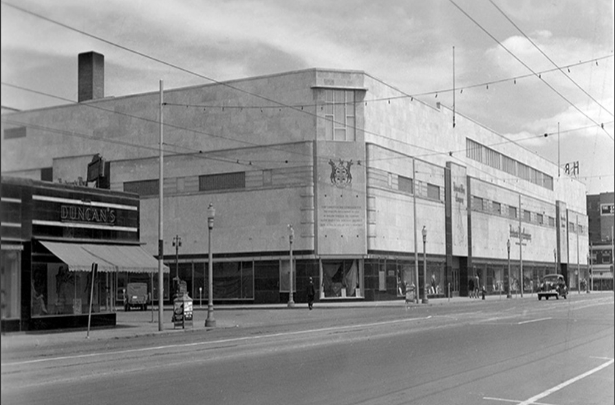

Another site under consideration was in the vicinity of the Hudson Bay building (102 St. and Jasper Ave.). Lots were relatively cheap there, and it was possible to position the church so the altar faced east. But it was too close to the business section, with too many rundown buildings in the area, and there were problems with the soil. A third site considered was the original church (96 St. and 106 Ave.). But then they would have to tear down the existing structure, which was a costly proposition.
The site eventually chosen was in the vicinity of 96 St. and 110A Ave. As the minutes record, “it is a suitable place, just one block from streetcars running on three streets; a quieter location, near other churches; a rather nice neighborhood; there are eight lots altogether; there is room for a residence.” There were two problems: 1) the lots were a bit expensive and 2) in between the lots the church wanted was another lot with a house on it – they would have to purchase it. Two cars were sent out to examine the lots, and the conclusion was that this was the most suitable place for the new church.
The parish was able to save $45,000 towards the new church by October 1948. By August of the next year it had saved $60,000. During his visitation to the parish on 7 May 1950, Archbishop Mstyslav symbolically broke the ground with a shovelful of earth to initiate the building project. The actual construction began 14 September 1950. The church structure was completed by the middle of 1952. Later that year, on 31 August, Metropolitan Ilarion consecrated the cornerstone.
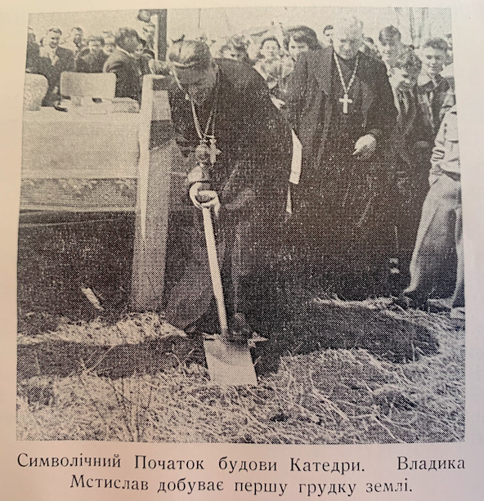

The New Church
The new church that was completed in mid-1952 is the structure currently used by the congregation of St. John’s at 10951-107 St. It was consecrated by Metropolitan Ilarion (Ohiienko) on 17 May 1953. The parish’s original aspiration to build a church to accommodate six hundred was wishful thinking. According to the fire code, just over three hundred worshippers at a time can attend services in the church.

From Church to Cathedral, 1959
At least since Archbishop Mstyslav (Skrypnyk) replaced Archbishop John (Theodorovich) as its head in 1947, the Ukrainian Orthodox church in Canada entered on a path of normalizing its structure and its relationships with the rest of the worldwide Orthodox community. The culmination of this tendency can be considered the Eucharistic union with the Ecumenical Patriarch of Constantinople in 1990.
An important step on this path was the creation of a council of three bishops at the head of three eparchies. This was initiated by the sobor of 1951, which divided the church into three eparchies: the Eastern eparchy in Toronto, the Central eparchy in Winnipeg, and the Western eparchy in Edmonton. The latter eparchy was comprised of the parishes in Alberta and British Columbia. With the establishment of three eparchies, the head of the church, at that time Ilarion (Ohiienko) was raised from archbishop to metropolitan. Although the Western eparchy was created, there was no bishop immediately available to head it. In fact, the eparchy remained essentially a paper creation until an administrator was appointed in 1955. This was Fr. Yeronim Hrycyna, who had been pastor of St. John’s in 1933-40.
An extraordinary sobor held in Edmonton in 1959 finally chose a bishop for the Western eparchy: Fr. Hryhorii Metiuk was ordained to the episcopate on 5 July of that year. His ordination at St. John’s was the first episcopal ordination of the Ukrainian Orthodox church to take place in Canada. Fr. Hryhoriy took the name Andrew. With a bishop at the helm in the eparchy, St. John’s was elevated to the status of a cathedral parish.
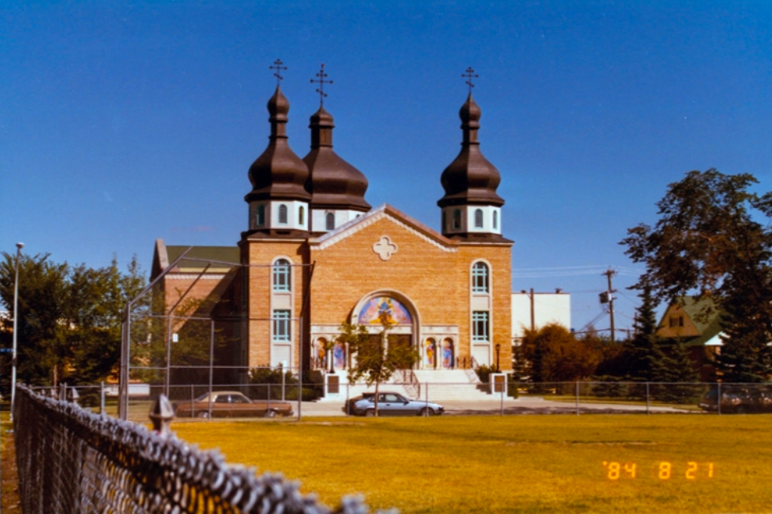

The bishops of the Western eparchy:

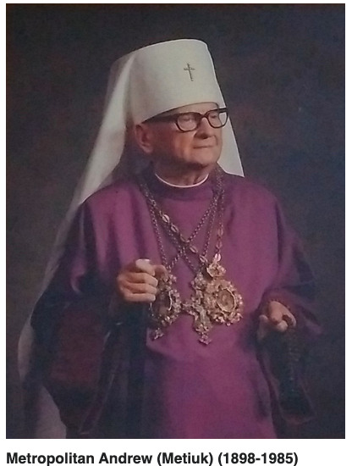

Bishop Andrew (Metiuk) was born in the Chełm (Kholm) region in 1898, attended seminary in Vilnius, and was ordained a priest in 1924. He earned a master’s degree in theology at Warsaw University. Like his close associate Ilarion Ohiienko, he came to Canada after World War II. He taught courses at the seminary in Winnipeg. Bishop Andrew was raised to the status of archbishop in 1963, and in 1975 he was elevated to metropolitan. He passed away in Winnipeg in 1985.

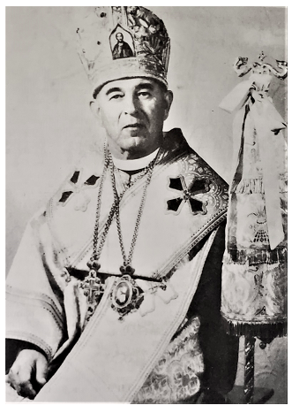

Archbishop Boris (Yakovkevych) was born in the Vinnytsia region in 1901, the son of a priest. He was ordained a priest in 1930 and served as a priest in the Volhynia region (then in Poland). He migrated to Canada in 1948. In 1963 he was ordained a bishop, serving as vicar in Saskatoon for the Central eparchy. He was made bishop of Edmonton and the Western eparchy in 1975 and died in office in Edmonton in 1984.

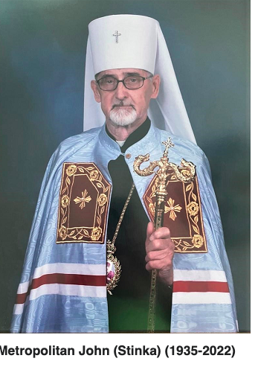

Bishop John (Stinka) was born in Buchanan, Saskatchewan in 1935. He spent some years as a teacher and, at least according to Wikipedia, as a kosher butcher. Ordained to the priesthood as a celibate in 1974, he served in parishes in Saskatchewan. In 1983 he was ordained to the episcopate, taking over as vicar in Saskatoon. Two years later he was transferred to the Western eparchy. He served there until 2005, when he was elevated to metropolitan. He retired in 2010 and passed away in Saskatoon in 2022.
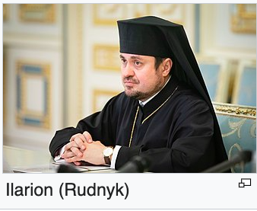

Bishop Ilarion (Rudnyk) was born, as Roman Rudnyk, in Lviv in 1972. He studied at the Kyiv Theological Seminary and then at the theological faculty of Aristotle University in Thessaloniki. He was tonsured as a monk in 1997 and took the name Ilarion. Three years later he was ordained to the priesthood, and in 2005 to the episcopate. He was the first Ukrainian hierarch in over half a millennium to be ordained by the Patriarch of Constantinople. He first served as a vicar in Spain and Portugal, but in 2008 was transferred to Canada as bishop of the Western eparchy. In 2018 and 2019 he played a major role in the creation of the Orthodox Church of Ukraine, which is recognized as canonical by the Ecumenical Patriarch. In 2022 he was elevated to the position of metropolitan of the Ukrainian Orthodox Church of Canada. He has also been appointed to the synod of the Ecumenical Patriarch.

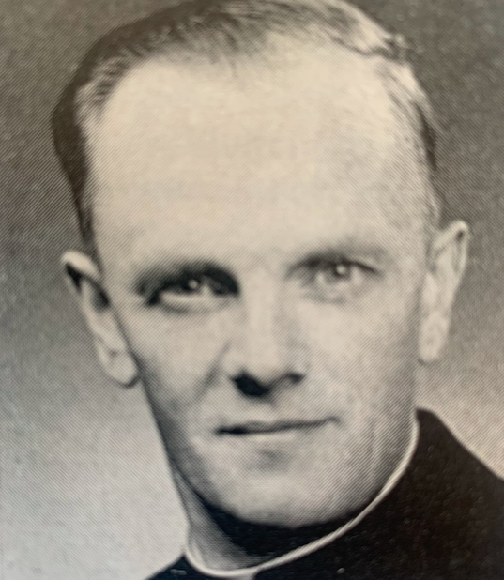

Fr. Alexander Chomiak, 1959-80
Fr. Alexander Chomiak was one of the longest-serving parish priests of St. John’s, only surpassed by Fr. Stephen Semotiuk, who would serve thirty years, beginning in 1992. One of Fr. Chomiak’s daughters, Myroslava Chomiak, spoke lovingly of her father, “a good man, a staunch Ukrainian patriot,” in an interview conducted on 22 September 2016.
Alexander Chomiak was born in 1915, a descendent of a Galician priestly dynasty: his father and grandfather were priests. He himself entered the Greek Catholic seminary in Przemyśl and studied theology for three years. He started in the 1936-37 academic year, so it appears that his studies were interrupted by the outbreak of the Second World War in 1939. He arrived in Canada after the war, around 1950, and was ordained into the Ukrainian Orthodox Church of Canada about a year later in Winnipeg. Before coming to Edmonton, he served in parishes throughout Saskatchewan. He never earned much as a priest, and in rural Saskatchewan parishioners gifted him and his family with the bounty of their farmland.
Fr. Chomiak was devoted to the spiritual and cultural care of the congregation. He took an active part in everything, all the organizations, all the big events. He contributed to the whole Ukrainian community, not just to its Orthodox component. He attended meetings almost every night, and he would visit parishioners in hospitals at all hours of the day. Fr. Chomiak was an extemporaneous, notes-on-a-napkin speaker, but he wrote out his sermons and they have been collected by his daughters.
The family lived in a manse on 111 St. and later moved to the cathedral manse. Since the hall had not yet been built, both Sunday school and Ukrainian Saturday school were conducted in the basement of the church and the manse. There were a hundred to a hundred and fifty children, and they had to be divided into many classes. “The weekends were busy with children coming and going,” Myroslava recalled. The Chomiak children spoke better Ukrainian than most of their peers. They spoke Ukrainian with their parents, but among themselves began using English. Most of their age group at church were second-generation Canadian, while the Chomiak children were first-generation.
Dobrodiika Chomiak was active in the Ukrainian Women’s Association of Canada. She never worked outside the home, but was devoted to supporting her husband and children.Their closest friends were other clergy families. Speaking of her parents, Myroslava said: “We were rich in love, their greatest gift.”
Fr. Chomiak passed away in office in 1980. He was just sixty-five years old when he died of a massive stroke, a brain stem infarction. He had had his first stroke fifteen years previously. He is fondly remembered by our older parishioners.

New Parishes
St. John’s parish, which was founded with twelve members back in 1923, had 1088 members by 1957; and of these members, only 128 were individual members – the rest were families. This reflected the growth of Edmonton after World War II, as the city attracted migrants from the Alberta countryside as well as migrants displaced by the war in Europe.

Year | Population of Edmonton
1945 | 111,745
1950 | 148,861
1955 | 209,353
1960 | 269,314
1965 | 371,265
1970 | 429,750

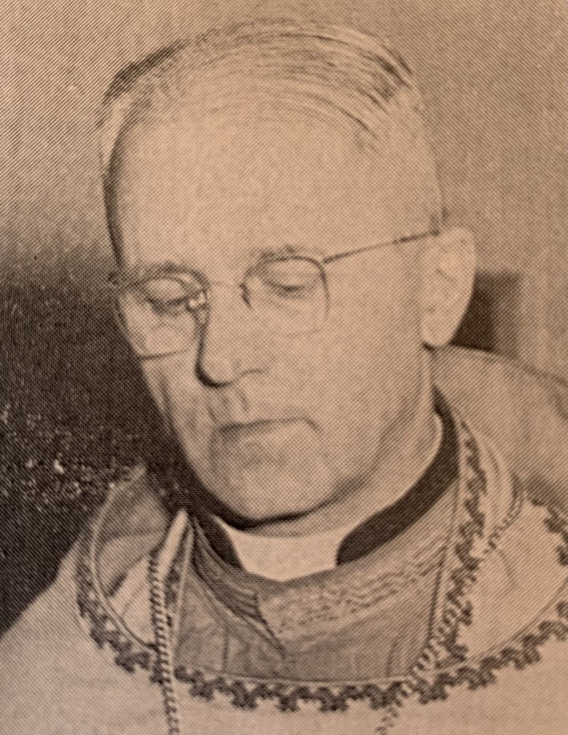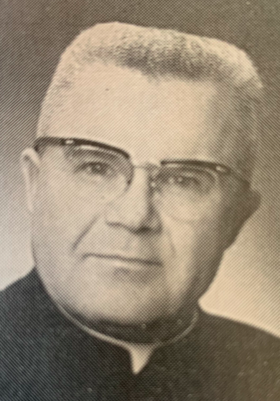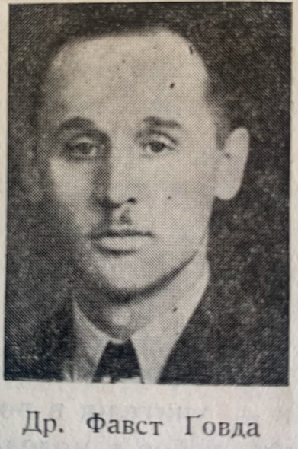

The church which the parish had built was not large enough to handle this explosion of population. For a while, in 1954-55, St. John’s had two pastors, Fr. Ambrose Chrustawka and Fr. Thomas Kowalishin, and they served two Easter liturgies in 1955 to accommodate the crowds of worshippers. The president of the parish board, Dr. Faust Gowda, suggested that two liturgies be celebrated every Sunday, but Fr. Kowalishin pointed out that this violated Orthodox tradition and that only the metropolitan could grant an exemption for the parish.
Not only was the population of Edmonton growing, but so was its area. Beginning in 1947, there was a long series of annexations, and in the early 1960s Beverly and Jasper Place were absorbed into the city. The new Ukrainian migrants were moving into these new areas of the city, not just into the old Ukrainian neighborhood around the church.
The influx of migrants posed pastoral challenges for the priests and board of St. John’s. At the parish general meeting on 15 December 1957, Kost Telychko aptly characterized the situation: “…In recent years many farmers, and especially farm youth, have been coming to the city, and these people often remain in the city outside the church, while in the farm country some of them belonged to the Ukrainian Orthodox church. As we go forward, we have to identify those who belonged to the Ukrainian Orthodox church on the farms and bring them around to our community, to our church.” There was particular concern among the leadership and clergy of St. John’s about migrants settling in North Edmonton who were being attracted by the Russian Orthodox church there.
St. John’s did everything in its power to resolve the situation, especially lending seed money to the fledgling parishes. The result was that within a few years three more parishes were founded in Edmonton, and another came into being somewhat later.

Name | Parish Founded | Church Erected
St. Elia | 1958 | 1958
St. Michael | 1959 | 1961
St. Andrew | 1959 | 1963
St. Anthony | 1974 | 1991

The Expansion of Infrastructure
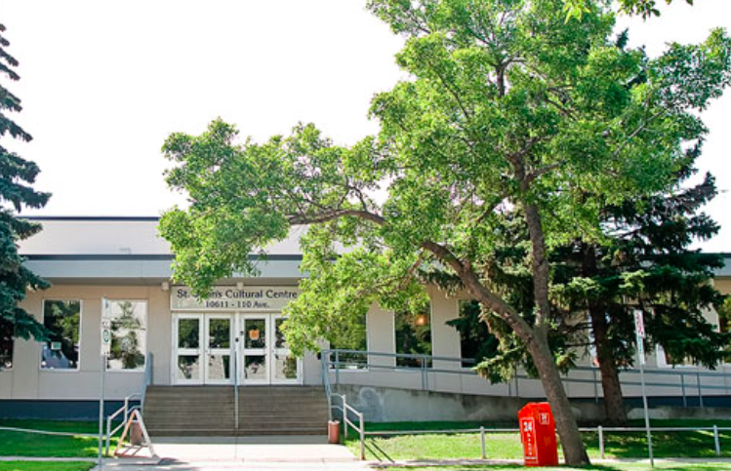

In 1958 the parish began to discuss constructing a new building to house the Sunday and Ridna Shkola schools and to serve as an auditorium for various gatherings. The cost of what was eventually to be called St. John’s Cultural Center was well over $250,000. On Sunday, 29 August 1963, Vladyka Andrew consecrated the land for the planned school and auditorium, and two years later, on 31 October 1965, he consecrated the finished construction, and the center was available for use. It has been the venue for many, many cherished events in the parish ever afterward. Of course, with the expansion of the parish’s physical plant, upkeep and renovation would demand additional funding and many hours of work over the following decades.
Recently, in 2022, the cultural center was enhanced by a series of mosaics by Theodora Harasymiw entitled “Our Heritage: The Past, The Present, and The Future.” This legacy mosaic celebrating the centenary of St. John’s was commissioned by the parish’s Ukrainian Women’s Association.
The parish had built a residence for priests, the manse, near the old church in 1930. After the erection of the new St. John’s church, a new manse was constructed in 1955. Its first occupant was Fr. Kowalishin. Not all the pastors of St. John’s have chosen to live in the manse, and it has constituted a bit of a money pit. At present, the manse is being rented out.
The parish has also contributed to institutions meant to serve the general Orthodox community. The proposal to establish a camp for youth at Pigeon Lake was first discussed in the parish in 1955. St. John’s has supported the camp, known as Camp Bar-V-Nok, with both funds and pastoral care. The parish also helped in the establishment and maintenance of St. John’s Institute, which replaced the former Mykhailo Hrushevsky Institute. The board of the newly planned institute purchased the former Robertson College from the University of Alberta in 1949, but the building proved too small and too dilapidated for the many Ukrainian Orthodox students who were coming to Edmonton for higher education. Over the years 1955-58 a new building was constructed on the same site, on Whyte Avenue. As the migration of Ukrainian Orthodox from the countryside into the city slowed to a trickle, the Institute no longer proved financially viable, and it was sold in 2020. Although the cathedral parish and the former institute were both called St. John’s, they were each named after a different St. John: the patron of the cathedral is St. John the Baptist, while the patron of the institute was St. John Chrysostom.

