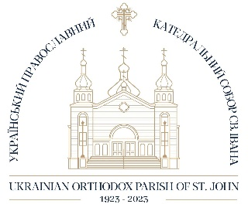

Membership Application Form
Ukrainian Orthodox Cathedral of St. John
10951 – 107 Edmonton AB T5H 2Z5

Date____________________
Family Name________________________________________________
Ukrainian Spelling (of family name)____________________________________________
Address__________________________________________City_______________________PC________
Home Phone Number__________________________
1st Adult – Given Names_____________________________________________ M __F__
Date of Birth_________________ Place of Birth________________________
Place Baptized_______________ Denomination of Baptism____________________________________
Occupation and Place of Work____________________________________________________________
Email address______________________________________ Cell Phone (opt.)_____________________
2nd Adult – Given Names____________________________________________ M__F__
Date of Birth_________________ Place of Birth________________________
Place Baptized_______________ Denomination of Baptism____________________________________
Occupation and Place of Work____________________________________________________________
Email Address______________________________________ Cell Phone (opt.)_____________________
Check which is applicable: Married__ Single__ Widowed__ Divorced__
Marriage: Date______________________ Name of Church_____________________________________
Address of Church______________________Denomination____________________________________
Children (dependents):
Name M or F Date of Birth
1.___________________________________________________________________________________
2.___________________________________________________________________________________
3.___________________________________________________________________________________
4.___________________________________________________________________________________
5.___________________________________________________________________________________
6.___________________________________________________________________________________

Do you currently maintain a membership at another parish? If so, please name the parish and give the location:______________________________________________________________________________
_____________________________________________________________________________________

Optional Information:
Names of independent children and their addresses:
_____________________________________________________________________________________
_____________________________________________________________________________________
_____________________________________________________________________________________
_____________________________________________________________________________________
_____________________________________________________________________________________

Signature ________________________________________

Membership Pledges Single Family
Church Membership $225 $450
Honorary Membership $200 $400

The following fixed charges are included in the membership privileges above
Consistory $158 per household
Western Diocese $15 per household

Upon completion of the application form, please drop it off at the administrative office or fax to (780) 425-3991.

____________________________ ________________________________
Priest’s Signature Membership Chair Signature

